Secure Transport – BGRS Initiated Feed

This document outlines the process to configure a 2-way feed (Inbound/Oubound) initiated by BGRS to the client.

Before starting the build out please ensure our Secure Tranport FTP Request Form has been completed by the requestor and is attached to the ZenDesk Task.

- Login to the Secure Tranport portal (http://10.115.1.97:444 or http://10.125.1.97:444 depending on the active datacenter) and select the Accounts menu
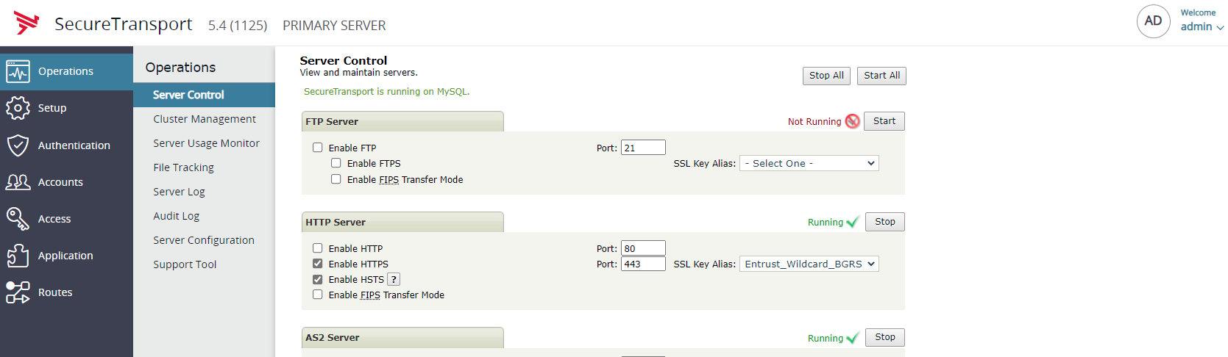

- In the Search field enter Twdxfer > Search > Click on the Account Name Twdxfer.
NOTE:This account is the primary account that contains all BGRS initiated feeds.

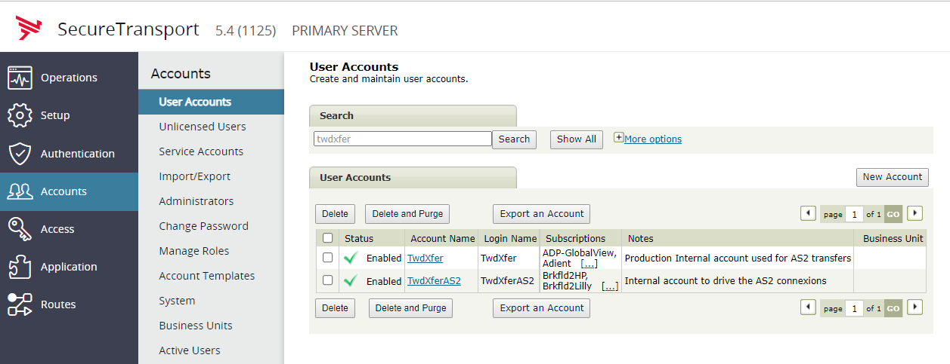

- Each feed has 2 requirements in the Transfer Sites tab
  - SSH Connection Site : Contains the connection string to connect to the client remote host including Server, Port, Folder Location on client end, ID, PWD and or SSH keys
  - Folder Monitor: As the name states this will monitor a folder for any files that need to be transmitted between the 2 site BGRS> Client and Client < BGRS

- To create a site click on Add New on the Transfers Sites page
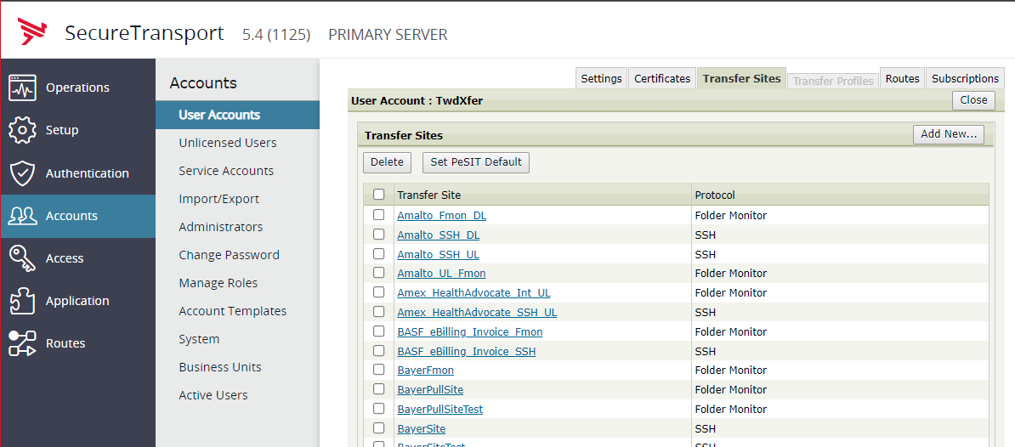
Required Fields:
  - Site Name: Typically naming format is ClientName_Function. In this example we will call the site United_SSH
  - Site Type: Partner
  - Transfer Protocol: SSH
  - Server: Details found in Secure Transport – BGRS Initiated Feed Form
  - Port: Details found in Secure Transport – BGRS Initiated Feed Form
  - Download Folder: Details found in Secure Transport – BGRS Initiated Feed
  - Download Pattern Setting:Usually we use *.* (pulls any and all files). Unless specified by the requestor in the Secure Transport – BGRS Initiated Feed Form
  - Upload Folder: Details found in Secure Transport – BGRS Initiated Feed Form
  - UserID/Pwd: Details found in Secure Transport – BGRS Initiated Feed Form
Note: Ensure you save the credentials in Beyond Trust
  - SSH Key: Details found in Secure Transport – BGRS Initiated Feed Form
Once all required fields are populated click on Save
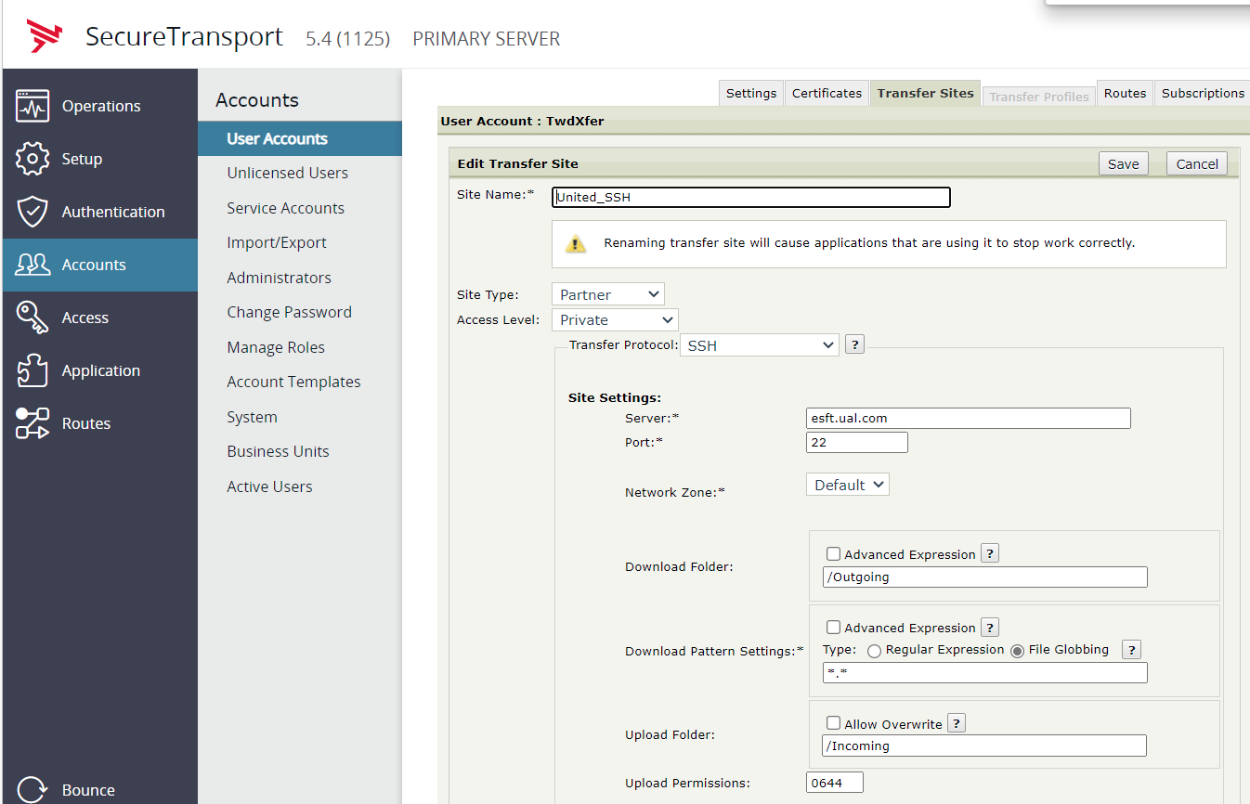

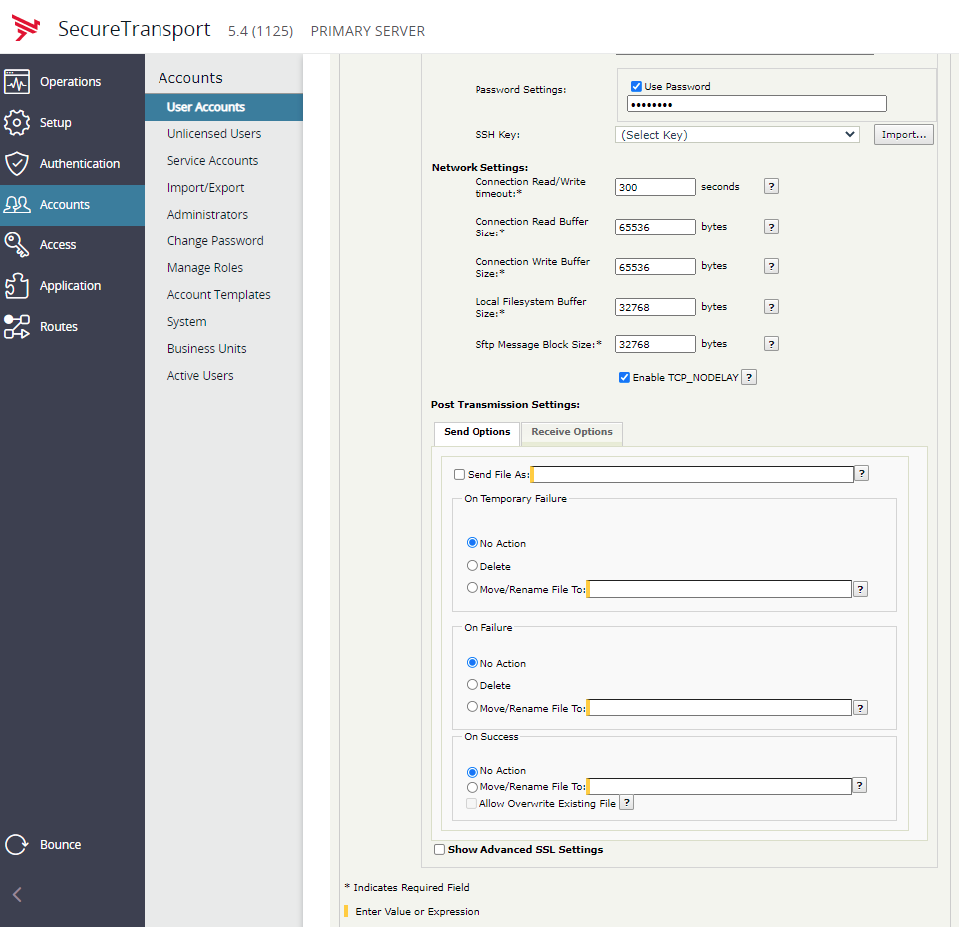

- Before configuring the Folder Monitor you should request SysEng to create a folder in Prod/QA Shares:
Example:
  - \\us\prod\SecureTransport\Transfers\[CompanyName]\Inbound
  - \\us\prod\SecureTransport\Transfers\[CompanyName]\Outbound

- On the Transfers Site menu click on Add New

- Here we will create the Folder Monitor.
  - Site Name: Typically naming format is ClientName_Function. In this example we will call the site United_FMon
  - Download Folder: Enter the outbound folder path
  - Download Pattern Setting: Usually we use *.* (pulls any and all files). Unless specified by the requestor in the Secure Transport – BGRS Initiated Feed Form
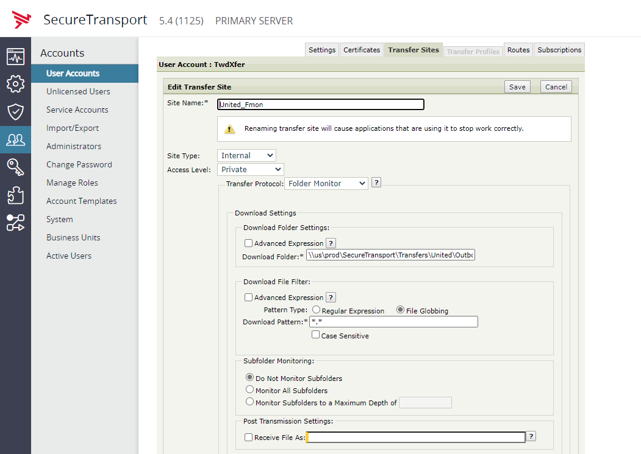

  - Upload Folder: Enter the inbound folder path
Once all required fields are completed click Save

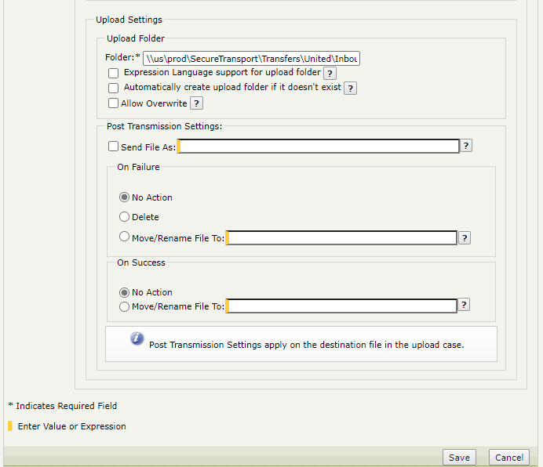

- Click on Subscriptions. In the “Subscribe To” dropdown menu select Basic Application
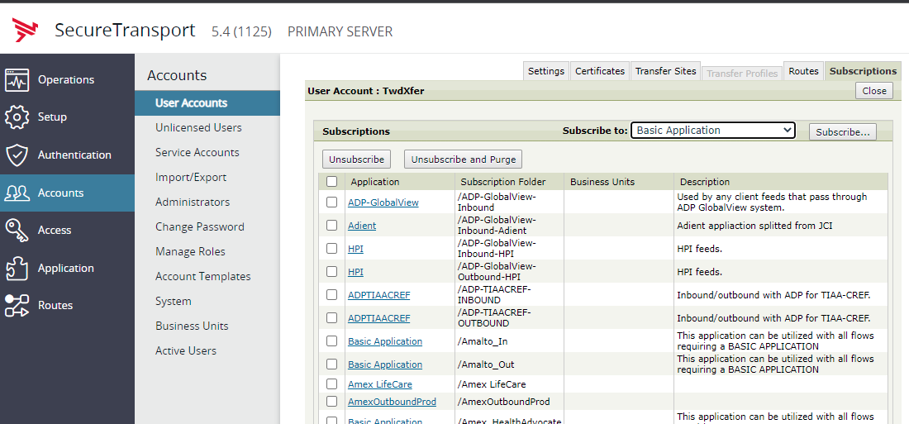

- Create Outbound Subscription. This is the job that will send files outbound
  - Subscription Folder: Naming pattern Company_Direction. In this example we will configured United_Outbound
  - Automatically retrieve files from: Select the folder monitor that we created earlier United_FMom
  - Schedule: If no schedule is configured the job will constantly poll for files to transmit which is not an effective use of resources. We should coordinate with the business and client to commit to a schedule. To configure an interval schedule, click on the configure button
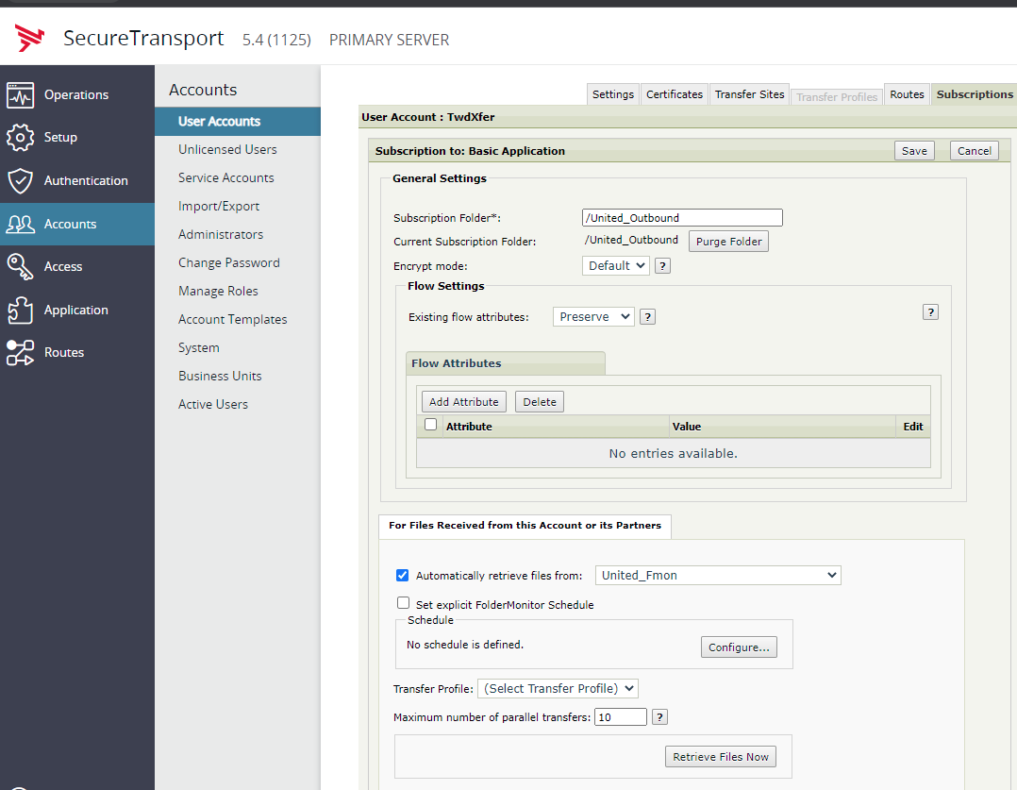

  - Send Files Directly To: Select the SSH connection we created earlier. In this example select United_SSH
  - On Success: Select Delete

Once all required fields have been completed click on Save.
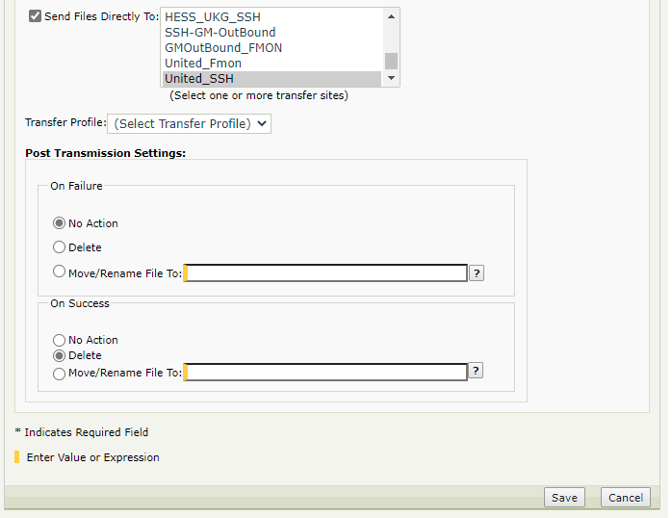

- Create Inbound Subscription. This is the job that will pull files from the client to BGRS
- Click on Subscriptions. In the “Subscribe To“ dropdown menu select Basic Application

  - Subscription Folder: Naming pattern Company_Direction. In this example we will configured United_Inbound
  - Automatically retrieve files from: Select the SSH Site. In this example select United_SSH
  - Schedule: If no schedule is configured the job will constantly poll for files to transmit which is not an effective use of resources. We should coordinate with the business and client to commit to a schedule. To configure an interval schedule, click on the configure button

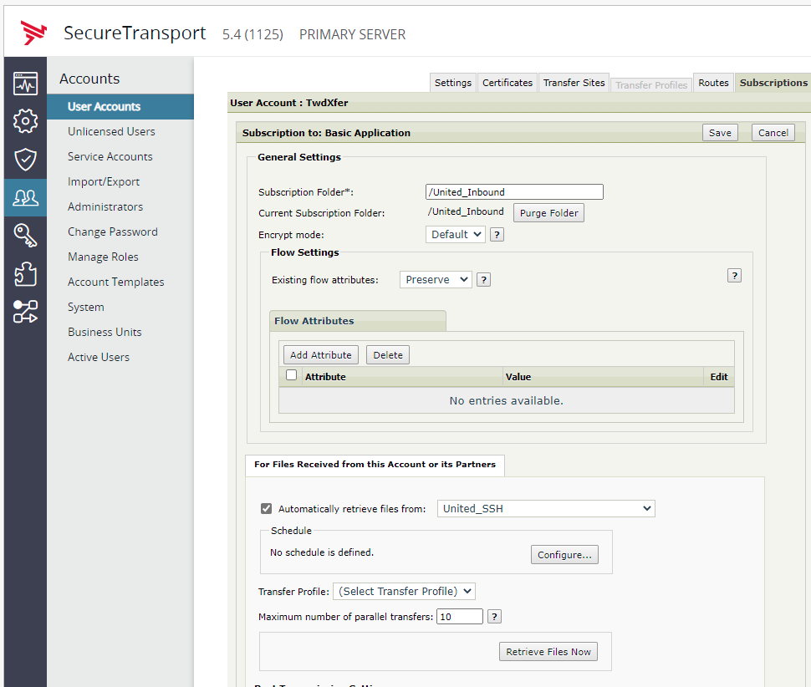

  - Send Files Directly To: Select the folder monitor. In this example select United_Fmon
  - On Success: Select Delete
Once all fields required fields have been completed click on Save.

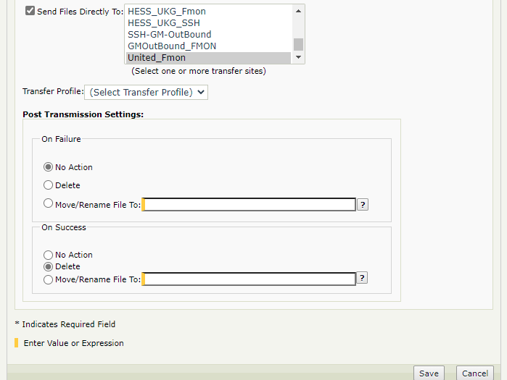

- Now that we have completed the configurations, we need to have the BGRS Business Team drop a test file into the Outbound folder as well as have the client place a file on their side for BGRS to pull down.

- Once both inbound and outbound Subscriptions have run click on the Operations menu and then click File Tracking

- In the File field enter the name of the file that is being transmitted and confirm that the action was successful

