Power BI Create Workspace

Reference article from Microsoft Create the new workspaces - Power BI | Microsoft Docs

- Login to https://app.powerbi.com/home using your administrative account
- Click on the Workspaces menu option and then click “Create a workspace”
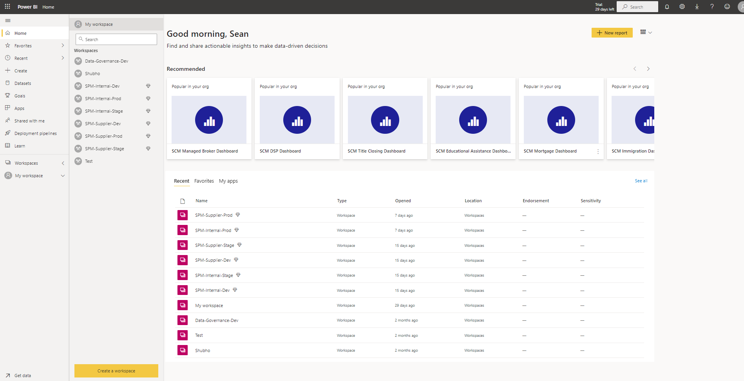

- Enter the name of the Workspace and provide a description. Then click Save
NOTE: Details will be provided by the requestor
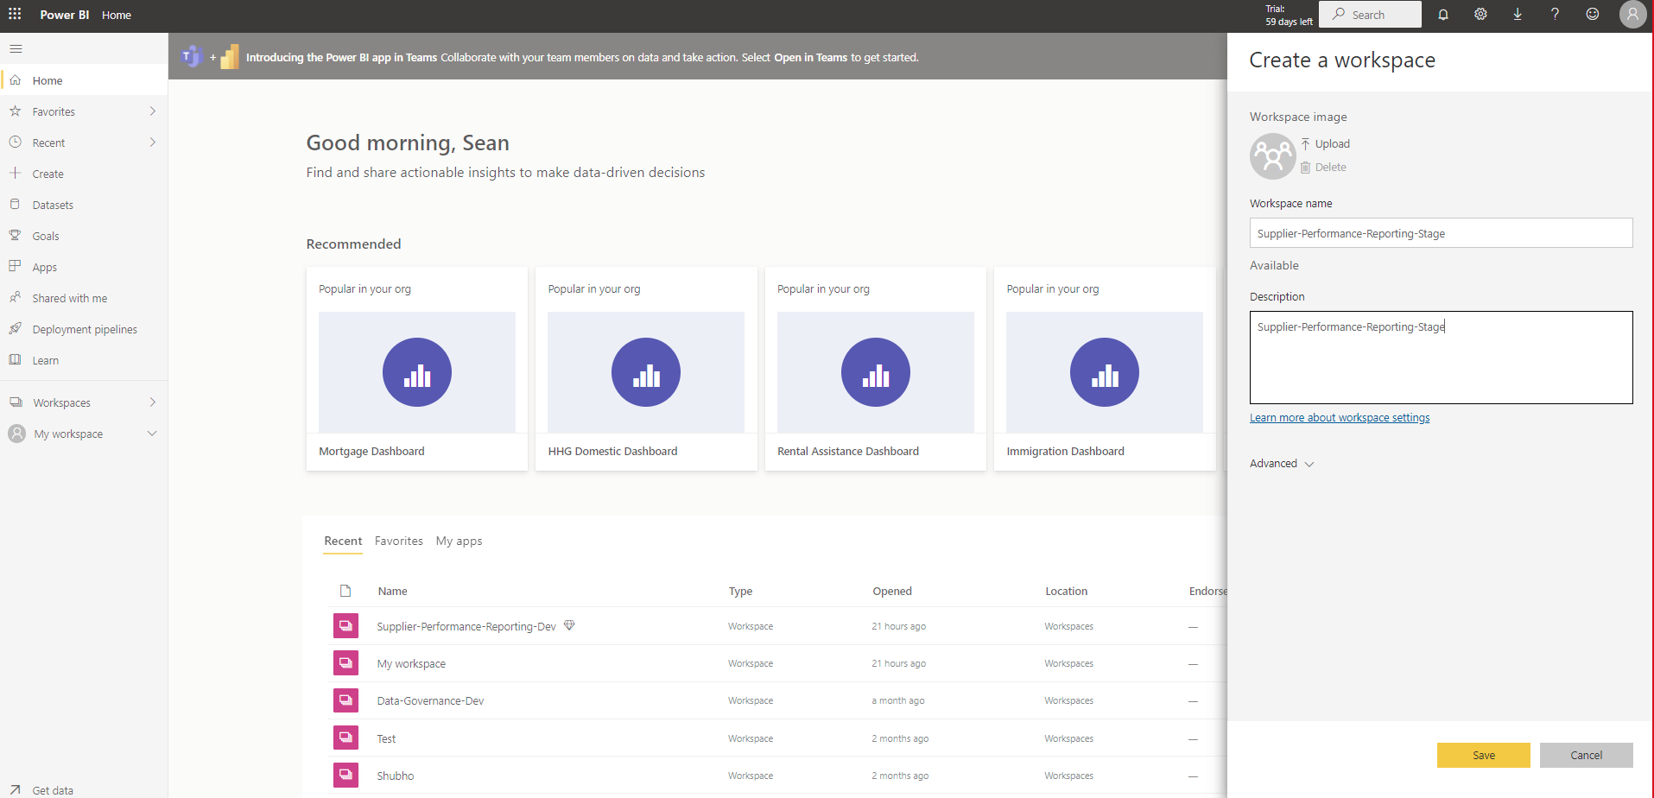

- Under the Workspace menu locate the Workspace you just created and click on the name
- Click on Access to add users to the Workspace
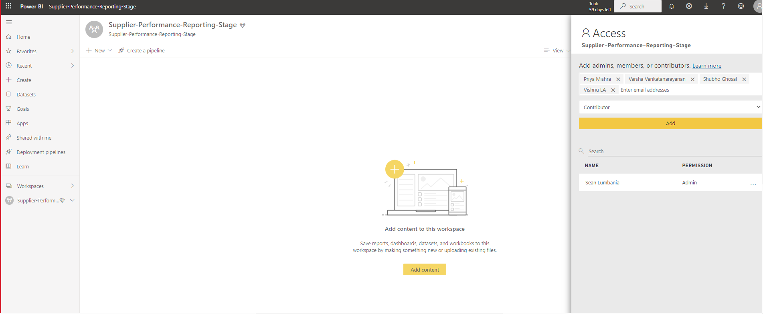

- Add Service Principal account (PowerBI-Embedded) as member. This is required as it provides authentication for embedding PowerBi dashboards to third party web portals.
- Add our team admin group ClientTechnologySupport_Admin as Admin so we have full access
- Add any required business users as request
