UIPath Update Renewal Process

We have recently renewed our contract with UIPath. Below is the PDF containing our new licenses along with the license numbers.

Reference: Ensure you are applying the right license to the corresponding environment and the correct amount of allocated licenses to the tenents.

Production 386758545612263003: Tenant Allocation 10-Default/35-US/5-US-Gov
Stage 386733384640470832 Tenant Allocation 3-Default/1-US/1-US-Gov
QA 386796132639583439 Tenant Allocation 1-Default/2-US/2-US-Gov
Dev 386717802715321660 Tenant Allocation 1-Default/2-US/2-US-Gov

- Login to UIPath Orchestrator and the change the tenant to host. For the username use admin and reference Beyond Trust for the password.

https://uipath.bgrs.com/
https://uipath-stage.bgrs.com/
https://uipath-qa.bgrs.com/
https://uipath-dev.bgrs.com/

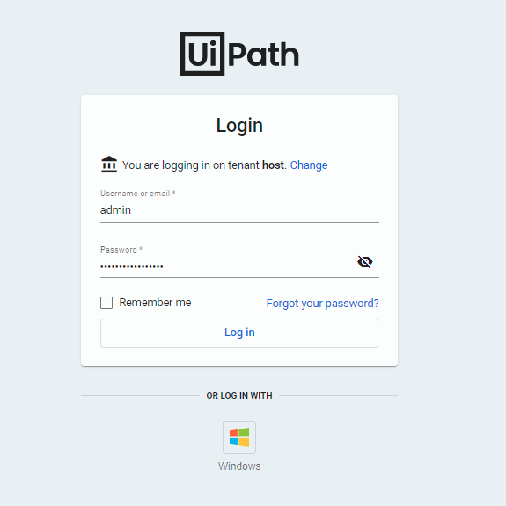

- On the menu click on License and then click on remove

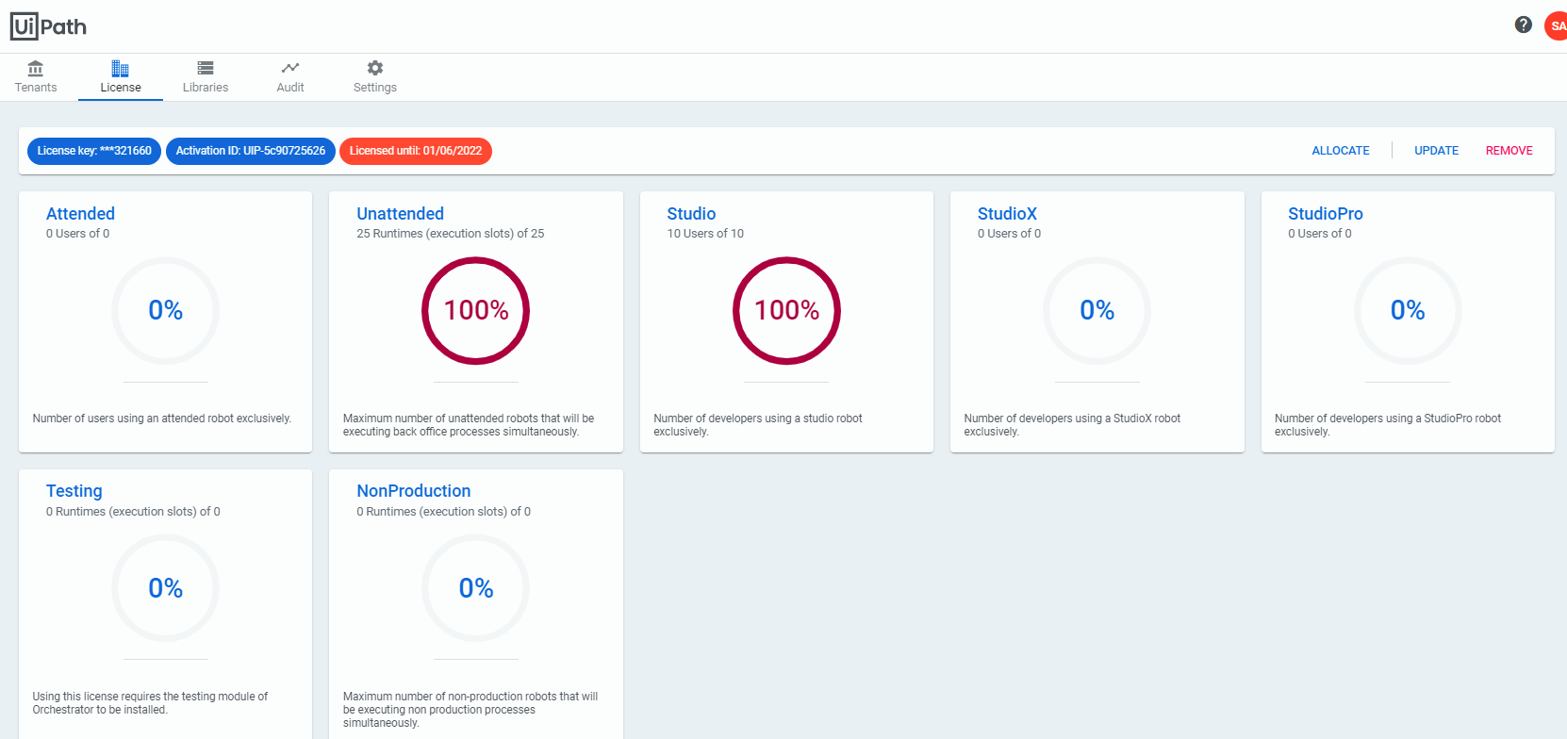

- Click OK on the prompt to confirm you want to remove the current license

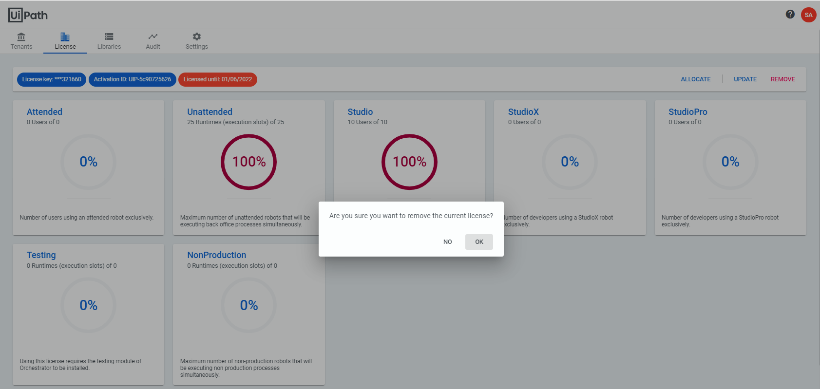

- On the License Menu click Active Online. In the License Key field enter the license number for the specific environment you are working on.

Note: For all non-production environments (Stage, QA, Dev) you must select Non-Production in the Environment Designation option.

Then Click Activate

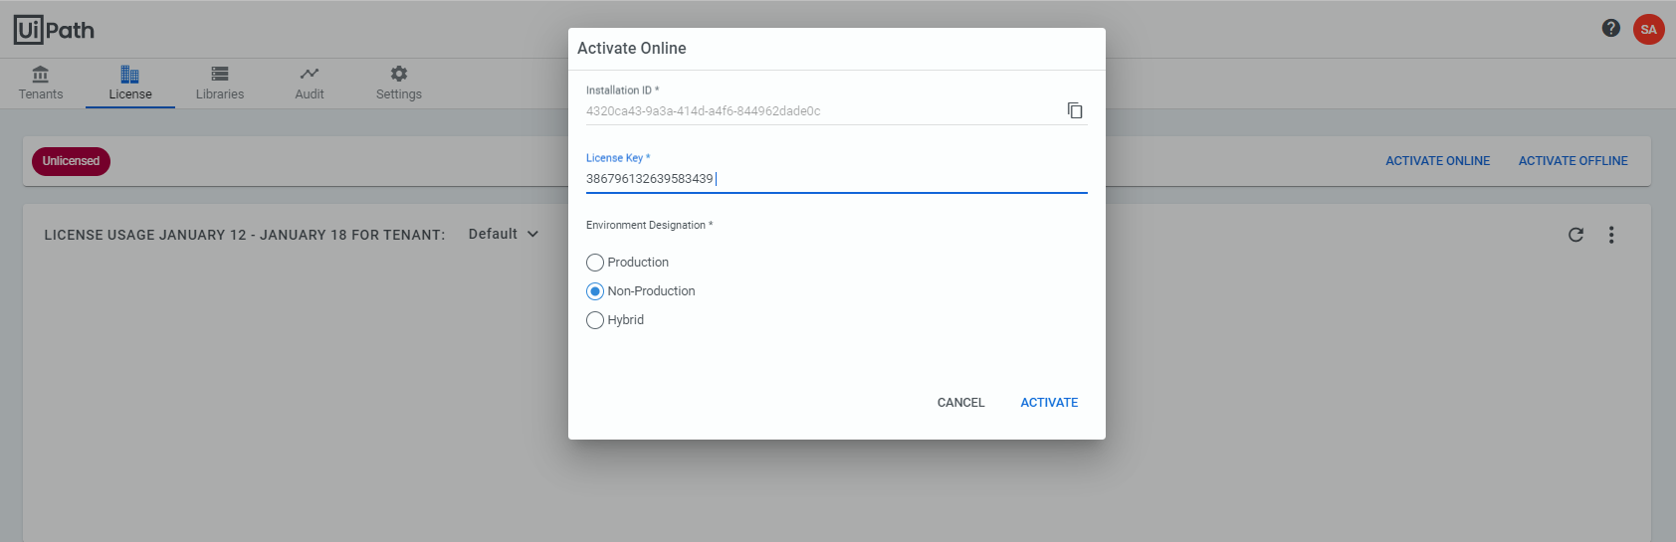

- Confirm License Key and License Until details match the license information in the renewal

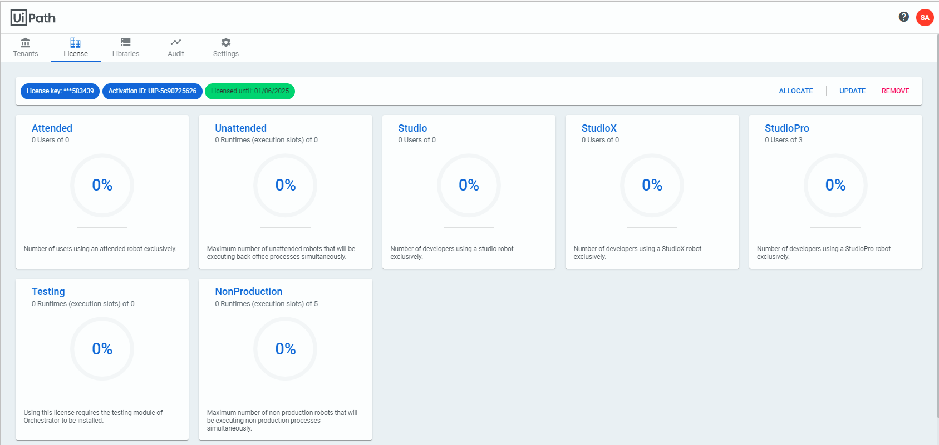

- Click Allocate > Select the Tenant you want to apply licenses to
NOTE: For the number of licenses to allocate to the specific tenant please review the section titled “Reference” on page 1

- Under NonProduction runtimes select the amount of licenses to allocate to the tenant then click Allocate (In this example we were apply licenses to the non-prod env)

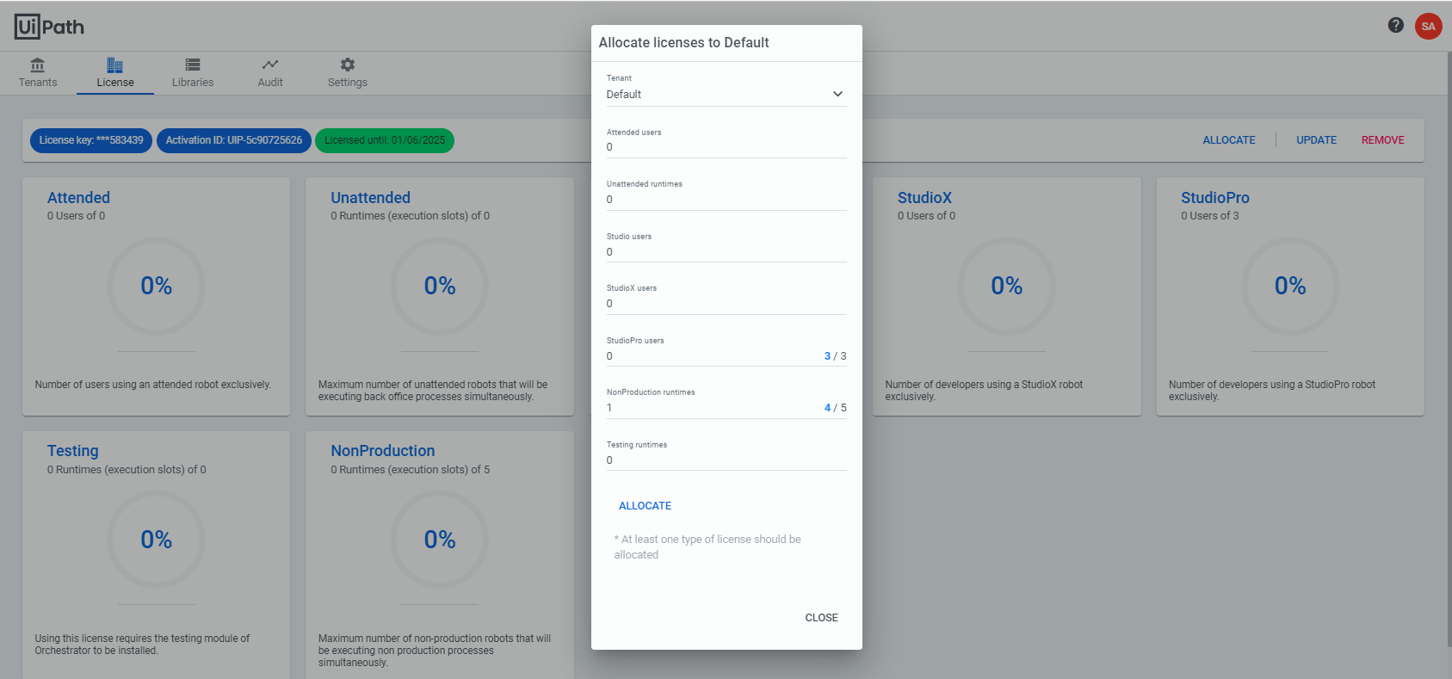

- Click on Tenant menu and validate the number of licenses allocated to the tenant is reflecting the correct number of licenses
