Grant Reporting Access in IRP iZone

Description: This procedure outlines the steps to grant user access into IRP Reporting in iZone. There are 3 groups which we will receive request for: Supervisor/TL, TPSP and Team. In this example the request was for Team access

- Login to IRP iZone User access

- In the Search Users field enter the Users ID and click Go

- Once inside the users profile place a checkmark in “IRP.IRPWEB.REPORTINGSYTEM” and the click Save

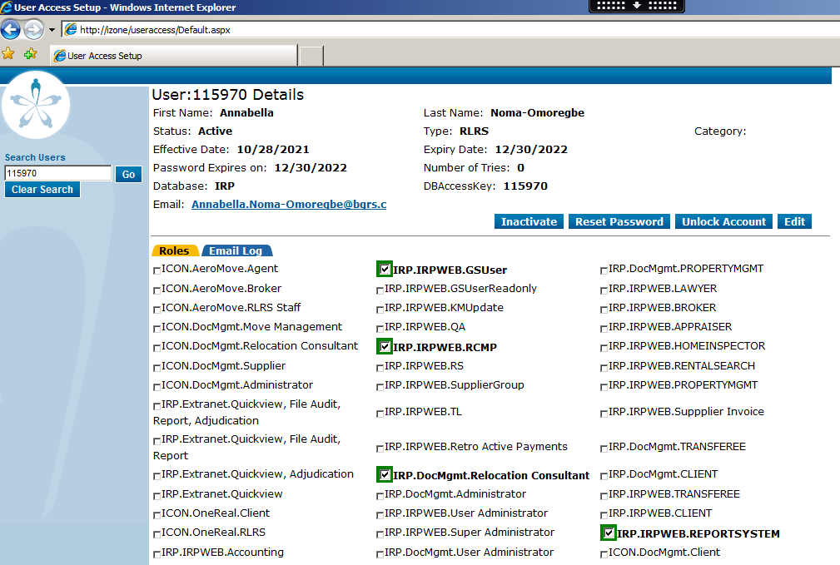

- Login to SQL 10.139.88.101\IRP

- Confirm if the user has a record in RSTMUserTabMapping table

select * from RSTMUserTabMapping where userid = '115970'

- If no record exists, please submit a DBCR for the below:

use irp
begin tran
INSERT INTO rstmusertabmapping (USERID, TABNAME, CREATEDBY, CREATEDATE, LASTMODIFIEDBY, LASTMODIFIEDDATE) VALUES
('115970', 'Team', 'slumbania', getdate(),'slumbania', getdate())
if @@ERROR > 0 or @@ROWCOUNT <> 1
BEGIN
ROLLBACK TRAN
RETURN
END
commit tran
print 'DBCR script completed successfully'

- Once the DBCR has been applied validate with user

