Grant User/Group Access to UIPath Orchestrator

- Login to the specific Orchestrator environment via the URL’s below:
- Production https://uipath.bgrs.com/
- Stage https://uipath-stage.bgrs.com/
- QA https://uipath-qa.bgrs.com/
- Development https://uipath-dev.bgrs.com/

- Select the appropriate Tenant you wish to provide access to

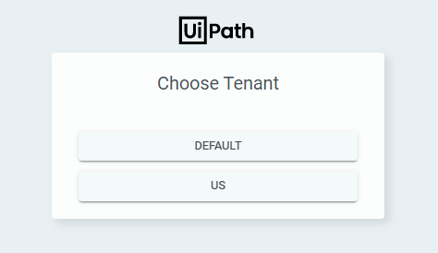

- Click on Tenant > Users and then Click on the icon labeled (Add Directory User or Group)

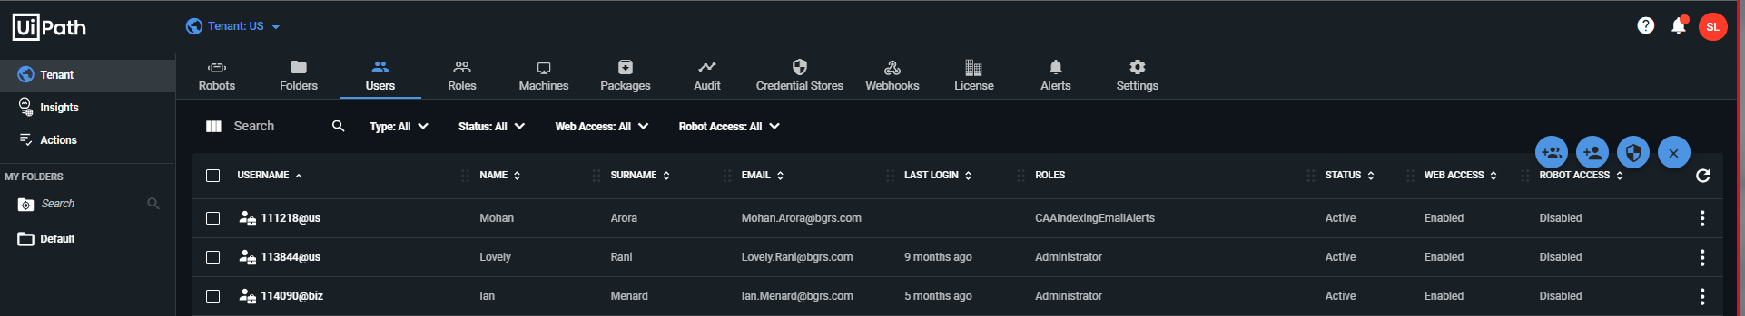

- Under the “User Details” fields populate the below:
- Domain Name: Select either US or BIZ
- Group or Username: Enter the AD Group or Username
- Roles: Click on the dropdown menu and select the required access

Once all fields have been filled out click on Save and then confirm with the users that they can access UIPath Orchestrator

