PowerBI Grant Access to Workspace

- Login to PowerBI using your Z account on https://app.powerbi.com/

- On the homepage click on the menu option “Workspaces” In the ticket the requestor will tell you which Workspace they need access to. In this example user is requesting access to SPM-Internal Prod.

- Click on the ellipsis icon beside the Workspace titled “SPM-Internal-Prod” and select “Workspace Access”
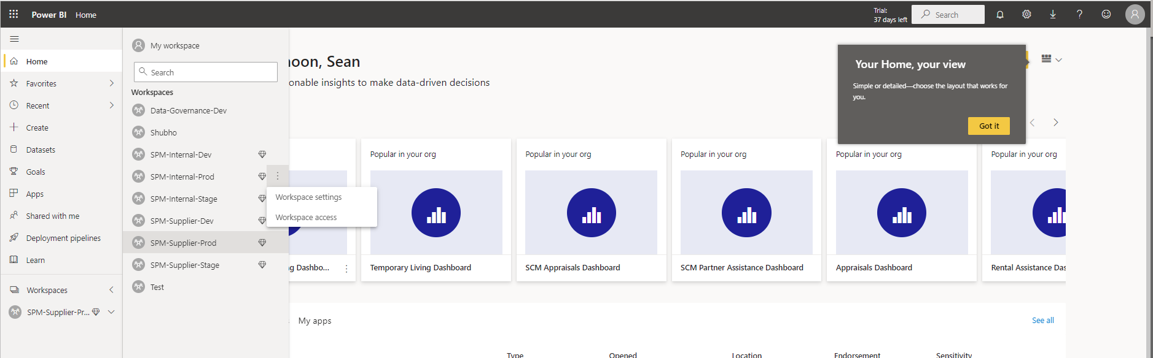

- Add the users Active Directory group in the field “Add admins, members or contributors”, select the level off access. In this example we will give the group “Member Permission” . The AD should be in the ticket however if not you will need to connect with the requestor
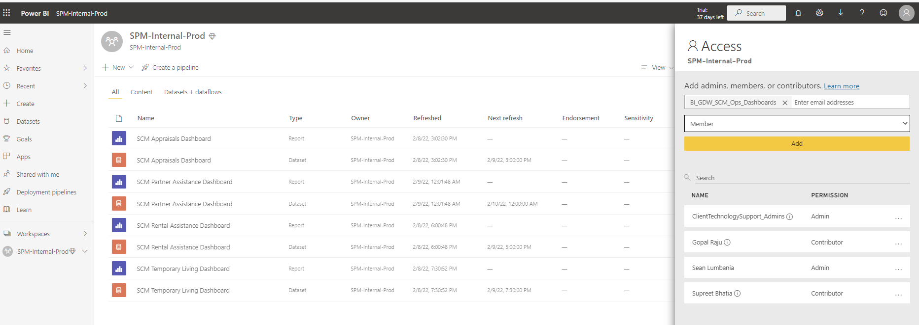

- Once you’ve completed filling out the required fields click on “Add”
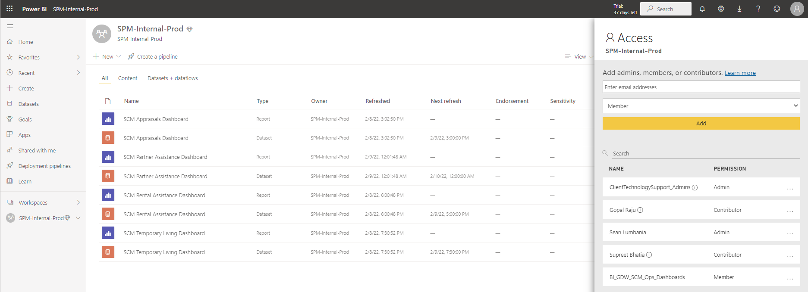

- Have the requestor validate they can access the WorkSpace

