D365 Download Latest Microsoft Platform Upgrade in LCS

1. Login to LCS Microsoft Dynamics Lifecycle Services
2. Select "BGRS – Implementation project"
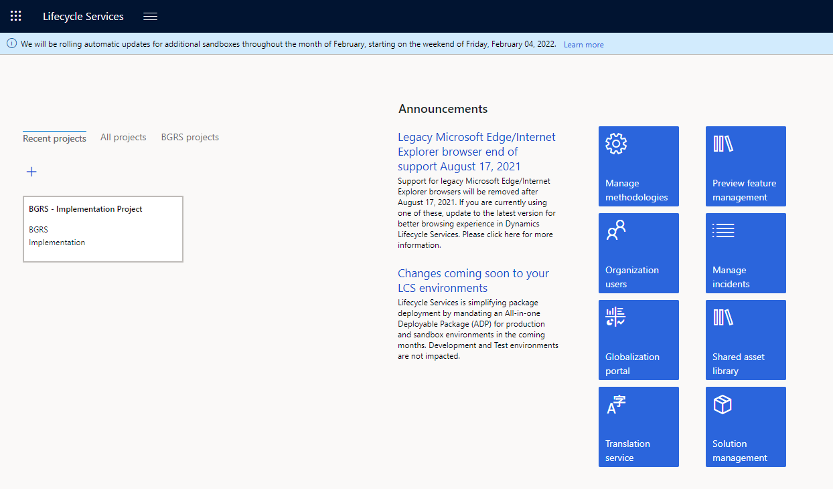

3. Click on “Full Details” for the environment you want to work on

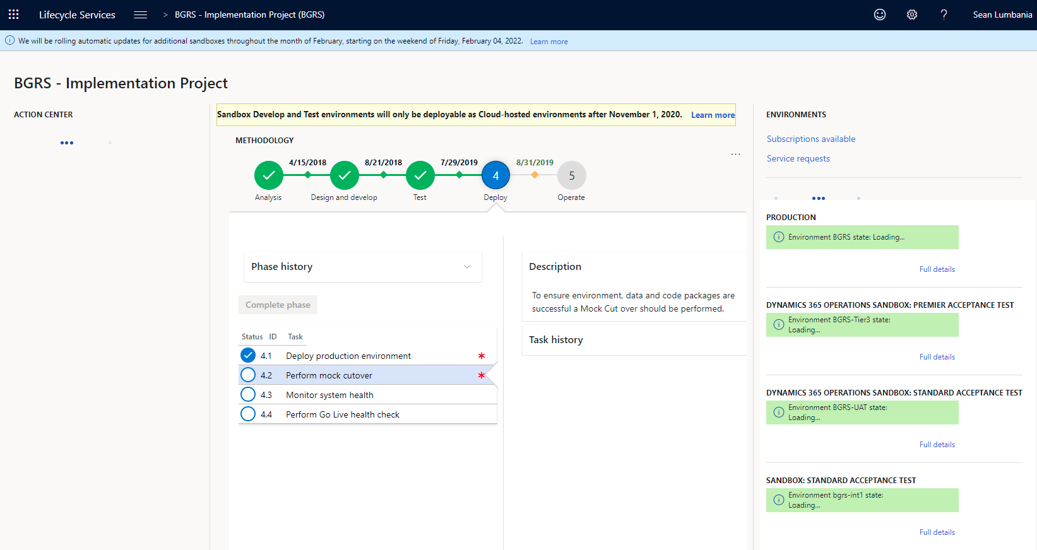

- Under “Available Updates” click on “View Update”
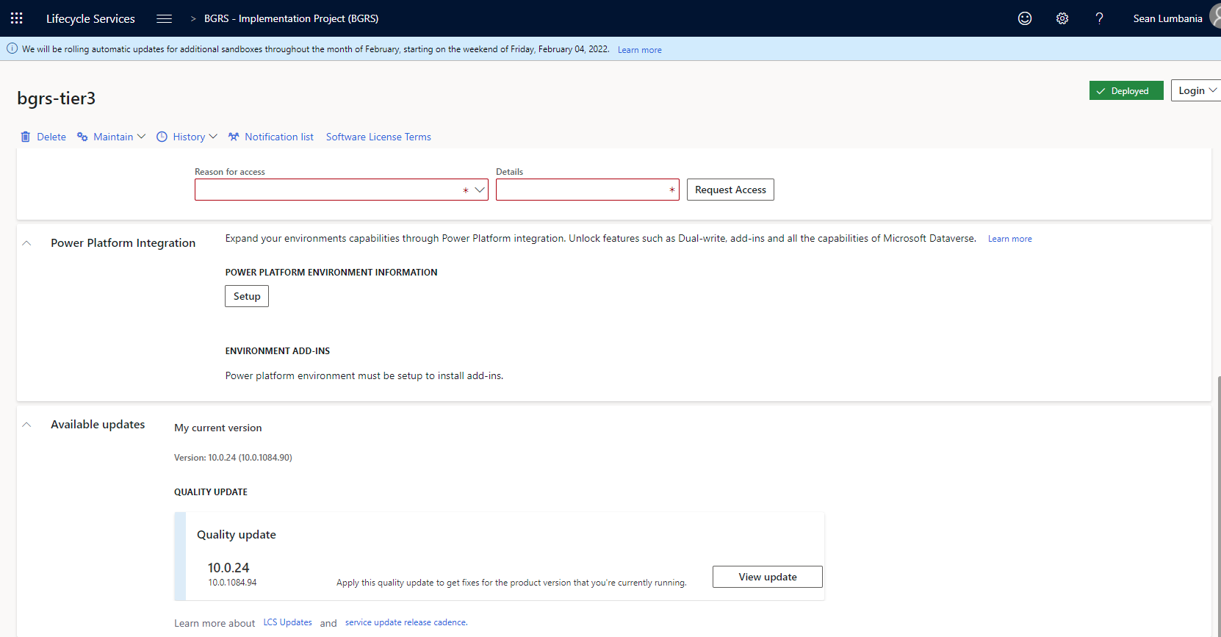

- Click on the button “Save Package”

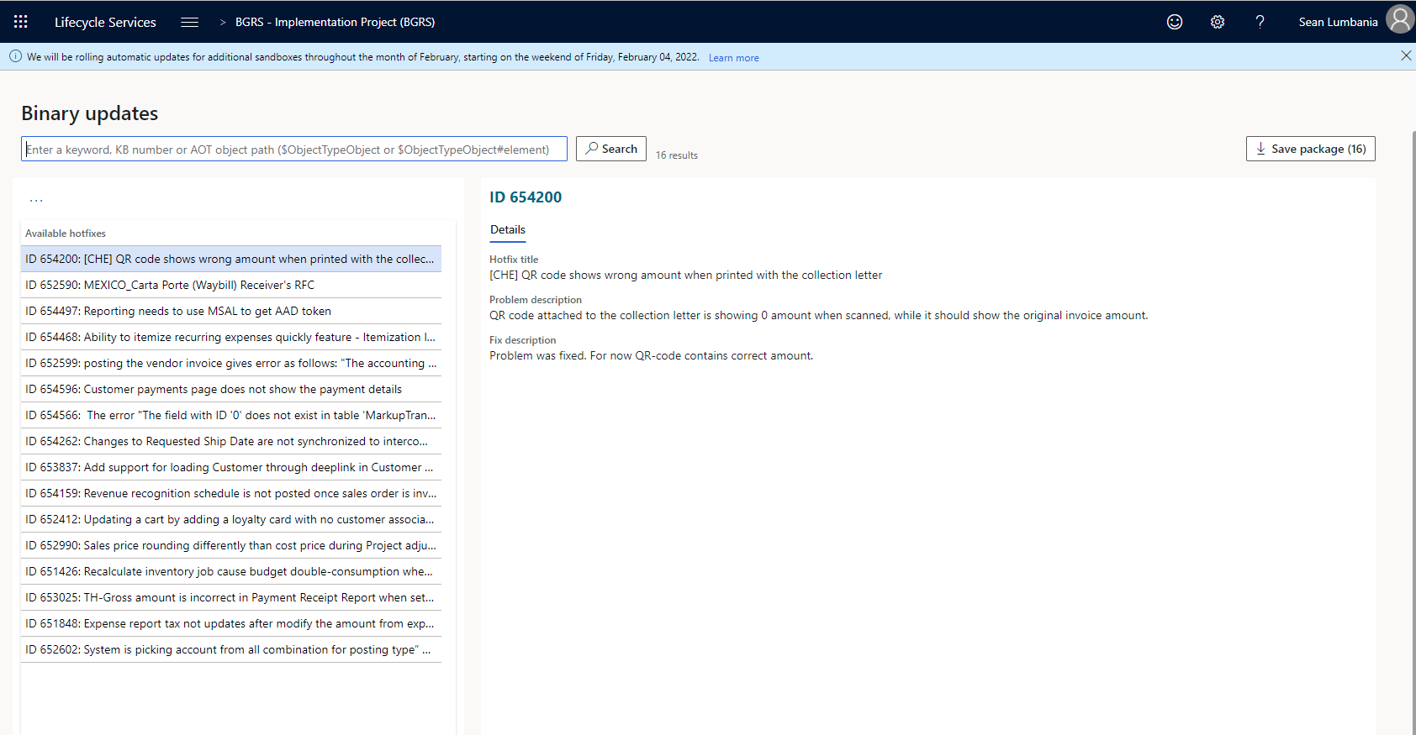

- Click on “Select All” then “Save Package”
- In the “Save Package To Asset Library” window enter the following:
- Name: PF_PlatformVersion_ProductBuild#
- In this example we will name the package PF_10.0.24_10.0.10.84.94
- In the Description enter:
  - Platform#
  - Product Build#
  - Download Date
- Once completed click “Save Package”
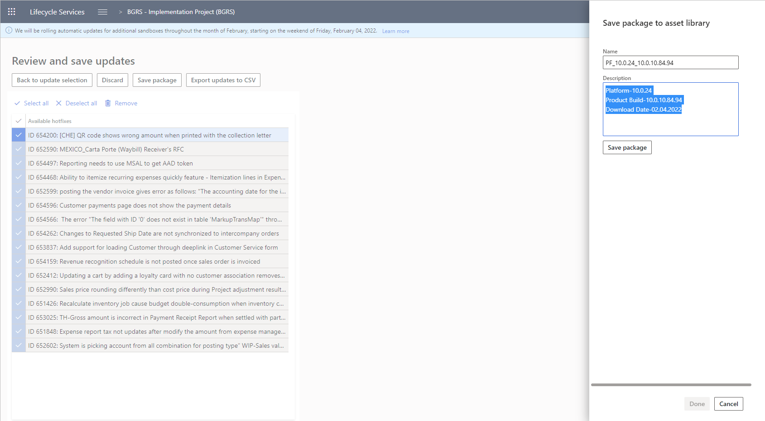

- Click Done
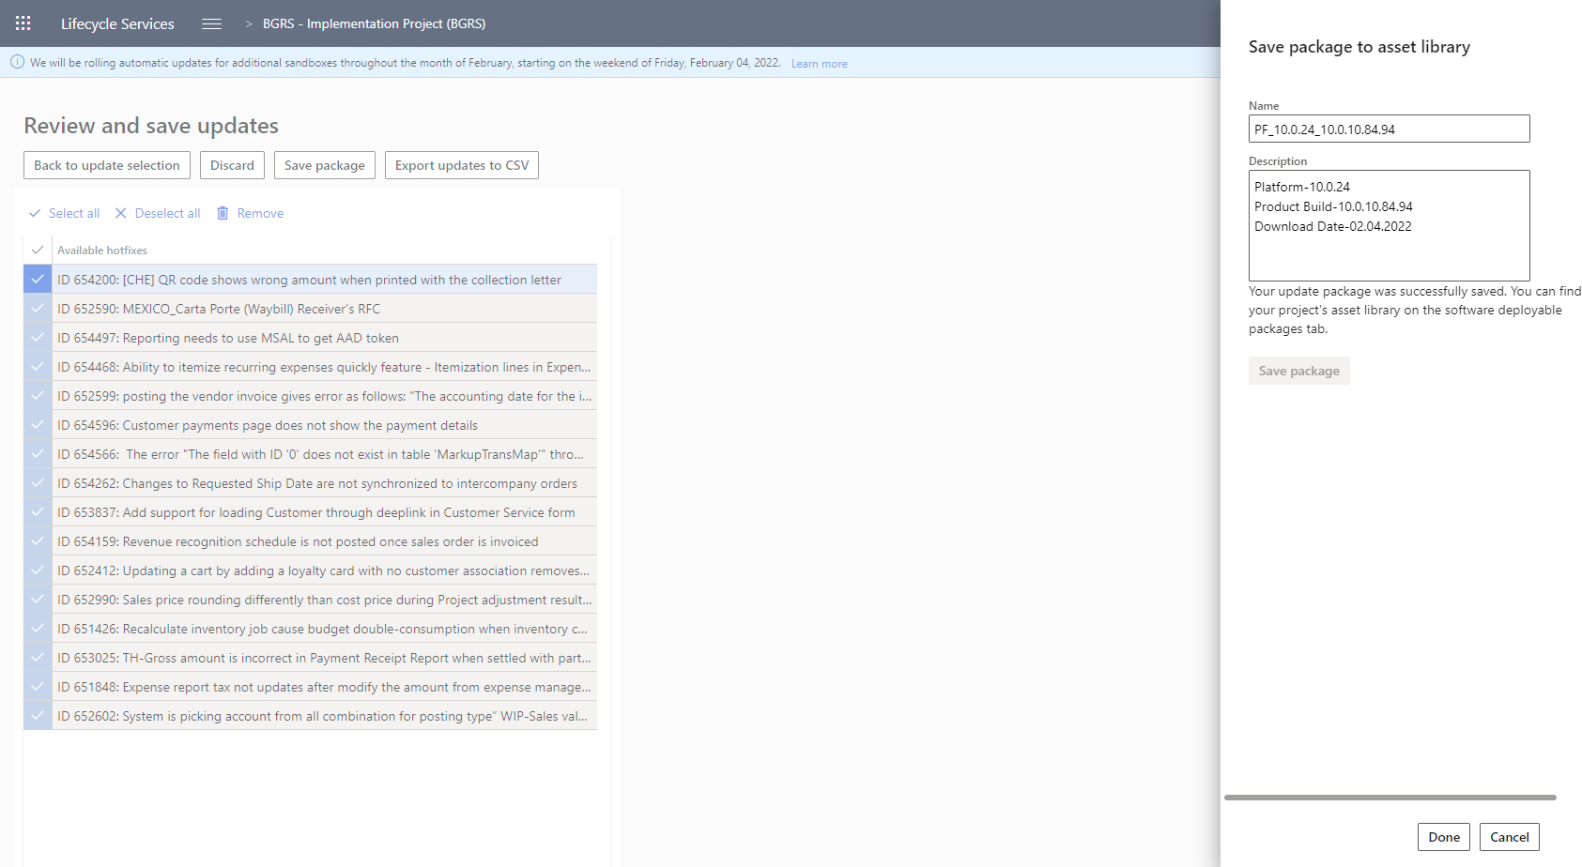

- Confirm the package was saved to the “Asset Library” by clicking on the hamburger menu and clicking on “Asset Library”
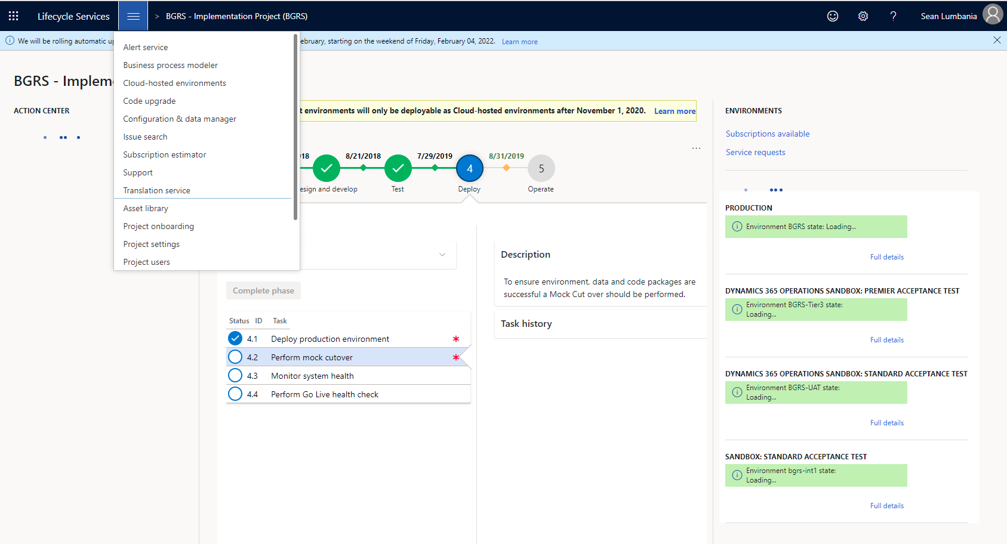

- Click on “Software Deployable Packages” and ensure the package name is present in the list
