VPN Login for Mobile Soft Token(US & International)

- Open Cisco AnyConnect on your login screen for windows with the icon with 2 monitors in the bottom right corner of window.

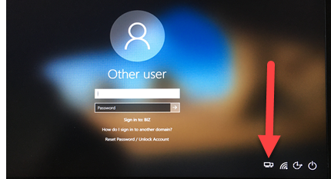

- Select appropriate VPN location(VPN United States/VPN APAC/VPN UK) from drop down:

EXAMPLE - VPN UNITED STATES
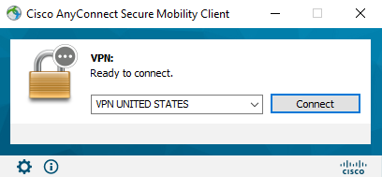

- Click Connect and you will get the following login:

EXAMPLE - VPN UNITED STATES
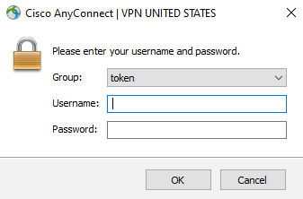

- Enter your Windows username in “Username” field.

- Launch the RSA SecurID Software Token application on your cell phone. Enter your 4-8 digit pin and hit Submit then enter the 8 digit number provided into the “Password” field.

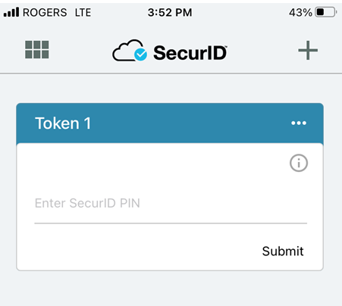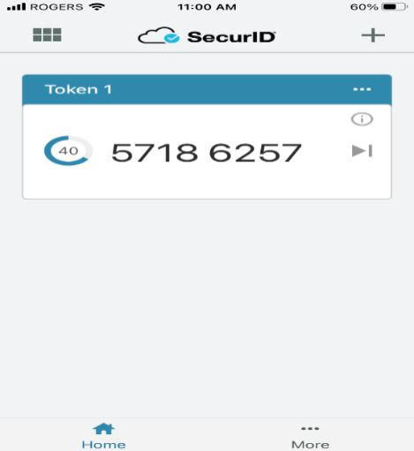
EXAMPLE - You would enter 57186257 into the “Password” field.

- Click on Accept to connect to VPN:

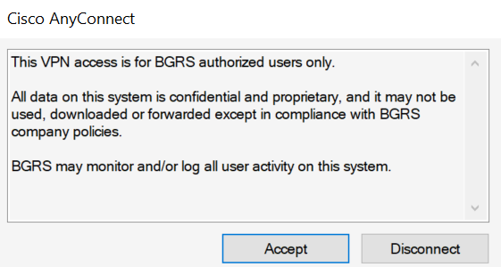

- Now that VPN is connected you will login to Windows with your User ID and Network Password.

