VPN Login for Hard Token(Canada)

- Open Cisco AnyConnect on your login screen for windows with the icon with 2 monitors in the bottom right corner of window.

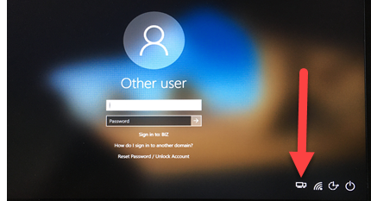

- Select the VPN CANADA location from the drop down:

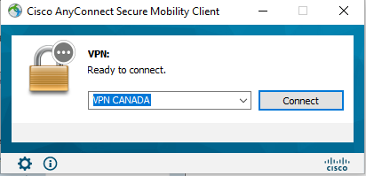

- Click Connect and you will get the following login:

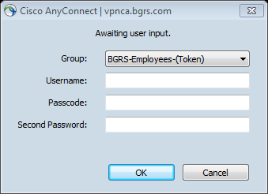
- Enter your Windows username in “Username” field.

- Enter your 4-8 digit pin followed by the 8 digit code on your hard token in the “Passcode” field.

EXAMPLE - Your pin is 1234. Your token code off the fob is 778966(as shown below):
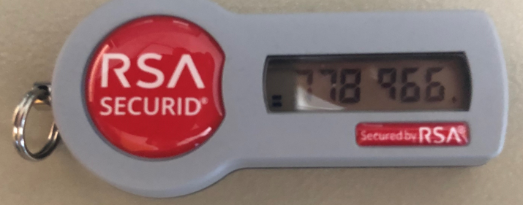
You would enter 1234778966 into the “Passcode” field.

- Enter your Windows password in the “Second Password” field.

- Click on Accept to connect to VPN.
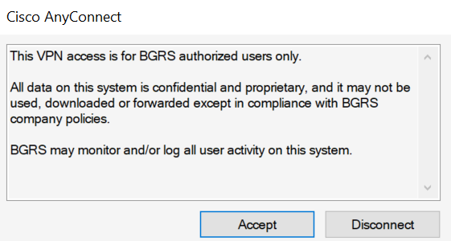

- Now that VPN is connected you will login to Windows with your User ID and Network Password.

