**ChangeGear – Manual for Change Approvers**

# Introduction

The ChangeGear Tool, available via the Web, lets you perform the functions necessary to successfully complete the change request process. This document is drafted to provide step by step guidance on how to approve change requests.

**Change Management Life Cycle**

Change management directs change requests through a life cycle that includes several stages.

**Overview of Approval Tab**

Approval is a formal decision to implement or reject a change request. Information previously collected for the change request plays a vital role during this phase of the change management life cycle.

Approvals are based on the Applications Impacted field. When an application is selected the approval, group is automatically added and notification to respective approvers would be sent.

**Email Notifications**

Email automations are enabled for specific actions and specific workflow statuses. Below is the list of available email notifications. When a certain action is triggered, applicable email notifications will be sent to the recipients.

|  |  |
| --- | --- |
| **Email Notification** | **Recipients** |
| When a change is Submitted | CM Team will be notified |
| When a change requires more info | Requester of the change will be notified |
| When a change is sent for approvals | Approvers will be notified |
| If a change is not approved | Approvers will receive first, second and Final reminders |
| When a change is rejected | Change requester will be notified |
| When an approver requires more info | Change requester will be notified |
| When a change is approved | Change Requester and Implementors will be notified |
| When task(s) are completed | Change requestor and Implementors will be notified about validation |
| When change is validated | Change requester will be notified |
| When a change fails Validation | Change requester will be notified |
| When a change is not closed 48 after Implementation | Change requester will be notified once in a day after 48 hours past implementation time |

**Approval emails**

Once the Change management team submits the change for approval, approvers will receive an email from [changear@bgrs.com](mailto:changear@bgrs.com) mailbox.

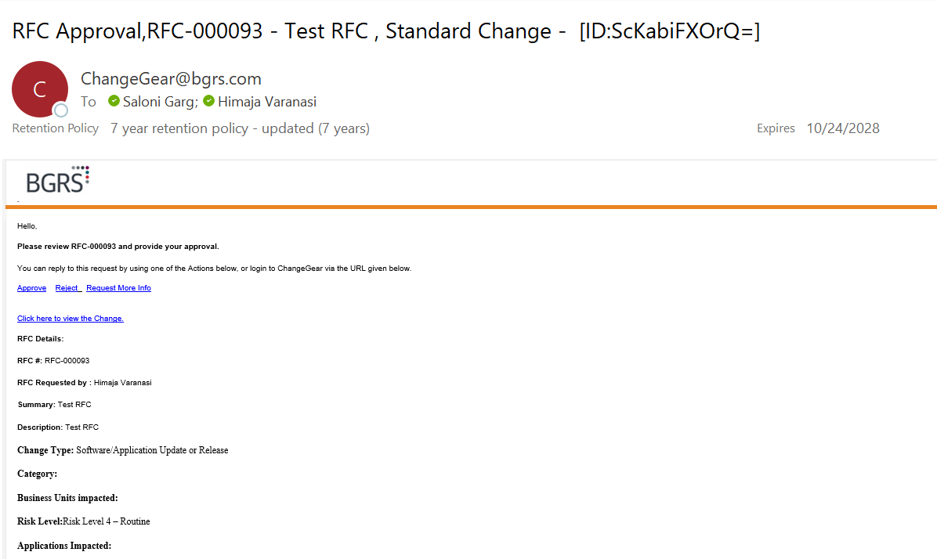

There are 2 options to approve/reject the change.

**Option 1: Approving from email**

Step 1- Click on Approve from the email itself.

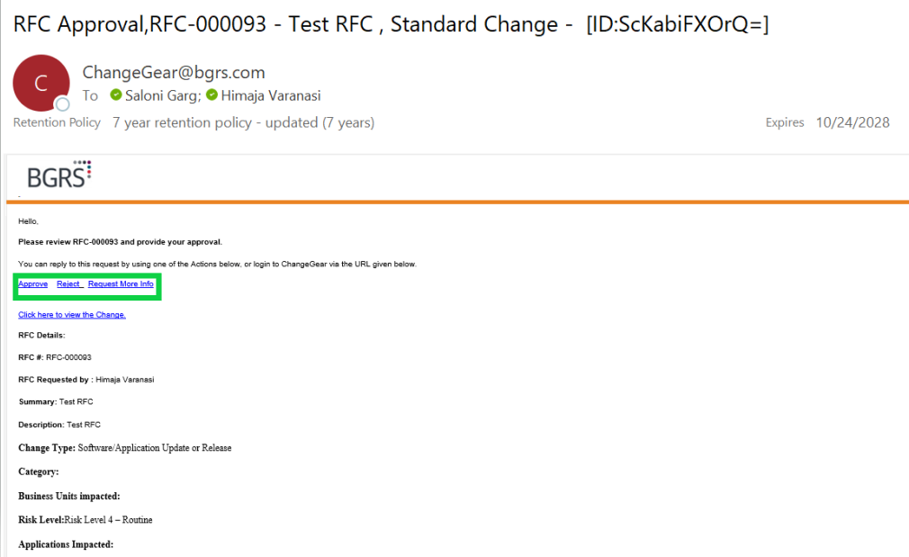

Step 2- Once you click on Approve, another email window will open with auto filled “From” and “To” details, click on send.

DO NOT modify anything to the body of email.

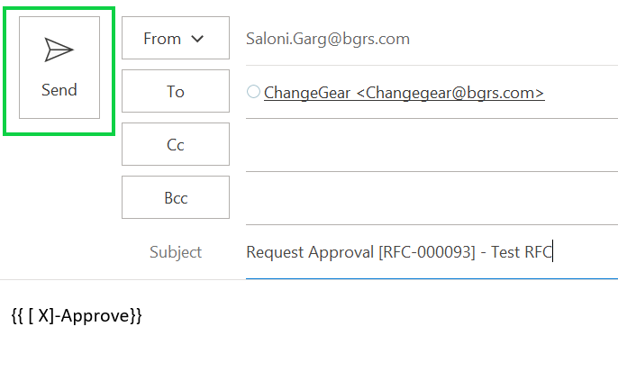

**Rejecting a change**

Once you click on Reject, another email window will open with auto filled “From” and “To” details. Add your comments to the comments section in the body of the email and click on send.

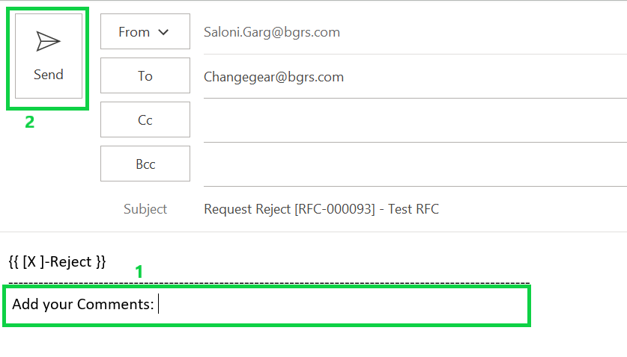

**Request More information**

Once you click on Request More Info, another email window will open with auto filled “From” and “To” details, Add your comments to the comments section in the body of the email and click on send.

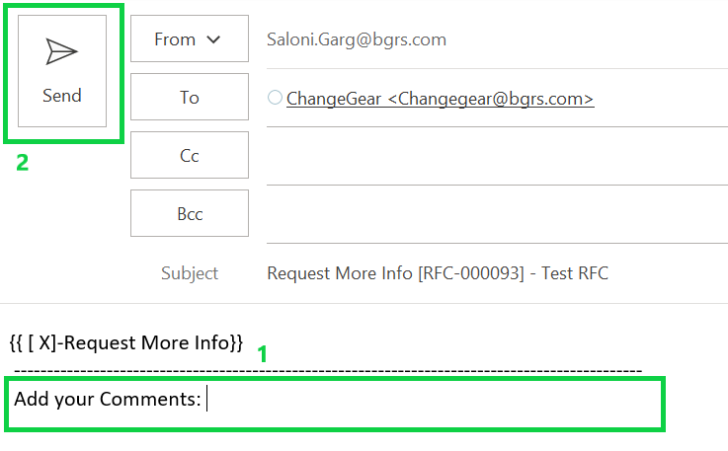

**Option 2: Approving from the tool**

Step 1- Approve/Reject/Request More Info from the change Gear tool.

If you wish to review & approve the change from the tool, click on “Click here to view the change “from the approval email you receive.

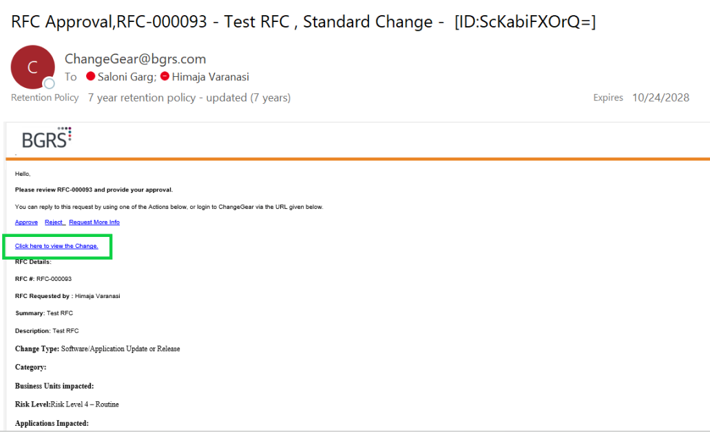

Once you click on “Click here to view the change”, you will be redirected to the change in the ChangeGear tool, from where you can review the complete change and based on your decision can approve/reject or request for more information.

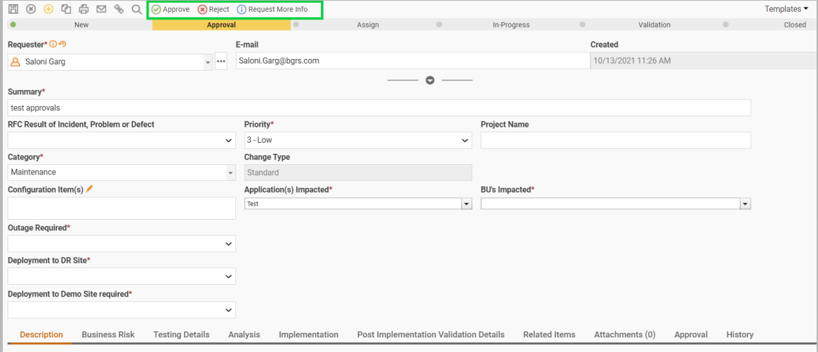

1. **Approving a change**

Once you click on Approve, another window will appear where you can add your comments in the comments box & click Ok.

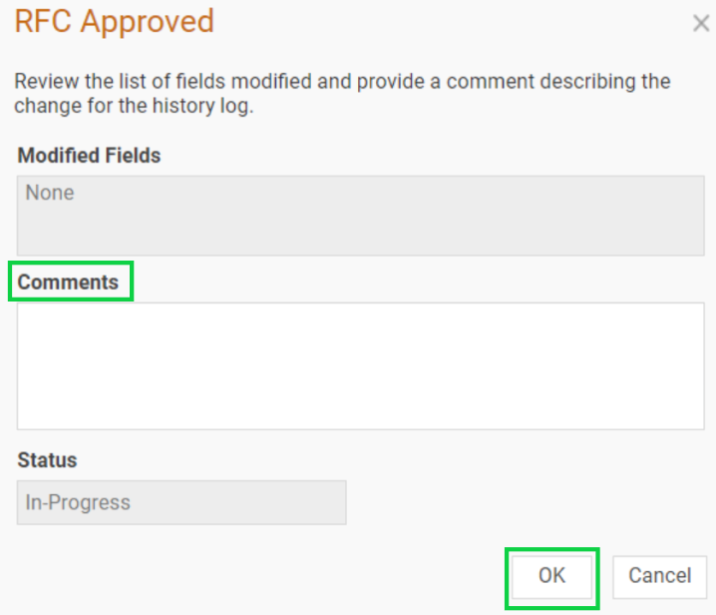

1. **Rejecting a change**

Once you click on Reject, a pop up window will appear you can add your comments in the comments box & click Ok.

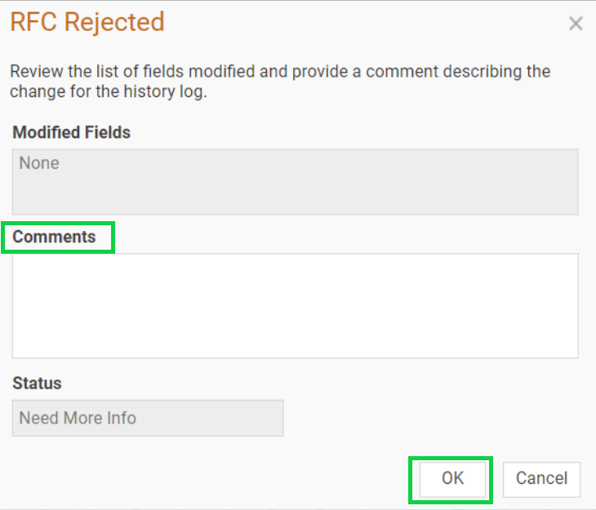

1. **Request More information**

Once you click on Request more information, another window will appear you can add your comments in the comments box & click Ok.

