**Import Favorites in Microsoft Edge**

The Microsoft Edge supports direct importing from other web browsers installed on your machine containing the favorites. Edge browser will store the imported favorites/bookmarks under the **Other Favorites** folder.

**Here are the steps to import favorites into the Microsoft Edge Chromium browser**:

1. **Launch** the [Microsoft Edge browser](https://browserhow.com/microsoft-edge-for-computer/) on the computer.
2. Click on the **More Options, aka 3 dots(**horizontal 3dots icon**),** situated at the top right.
3. Click the **Favorites** menu.  
   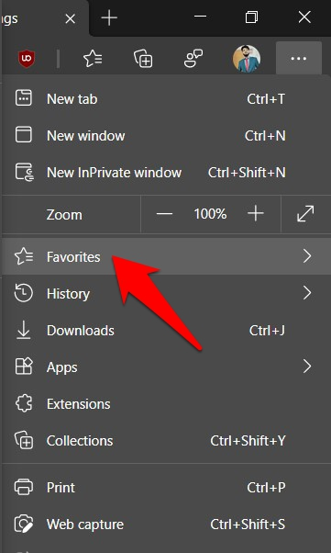
4. Click on the **More Options, aka 3 dots(**horizontal 3dots icon**),** situated at the top right of the Favorites menu.

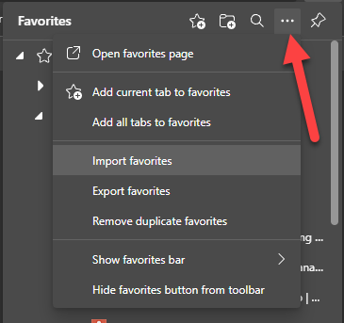

1. Click on **Import favorites** from the menu.  
   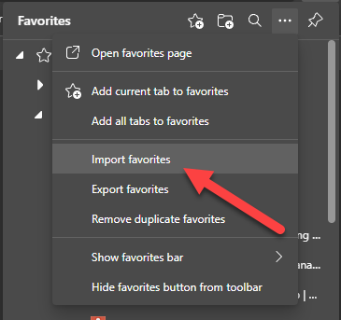

*It will list out all the browsers installed on your PC that support the import of bookmarks*.

1. Select the **desired browser** from the drop-down menu.  
   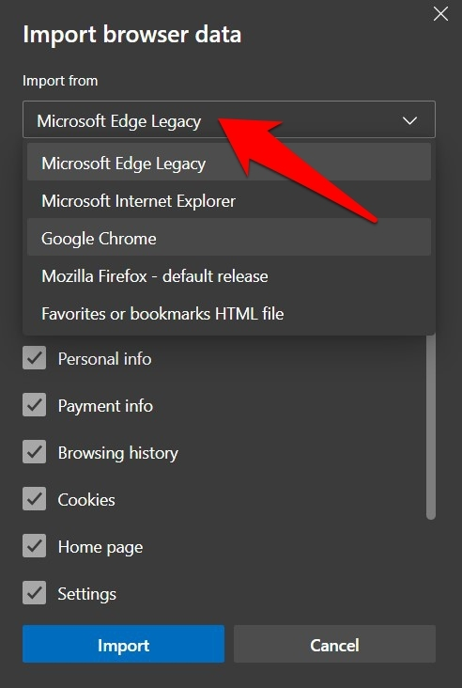
2. Uncheck everything else, and only keep the **Favorites or Bookmarks** option enabled.  
   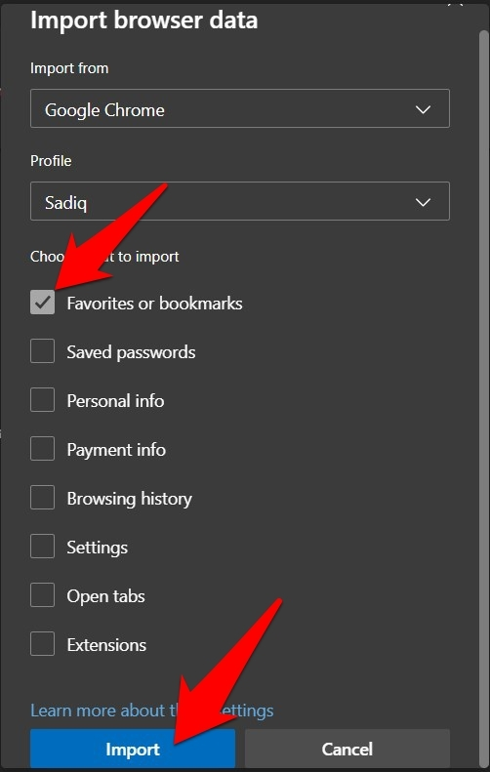
3. Click the **Import** button and wait for the process to complete.