Login to accessgrsi.bgrs.com
In the ticket you will receive the environment which to create the account for , an account to mirror while granting access as well as the Team ID.
Example
- QA iZone
- QA iZone User Access
- Training iZone
- Training iZone User Access
- Prod iZone
  - Note there is no icon for Prod iZone user Access. What you can do is once you launch Prod iZone you can open another tab in the IE Window and enter the url ttp://izone/useraccess/default.aspx to access Prod iZone User Access.
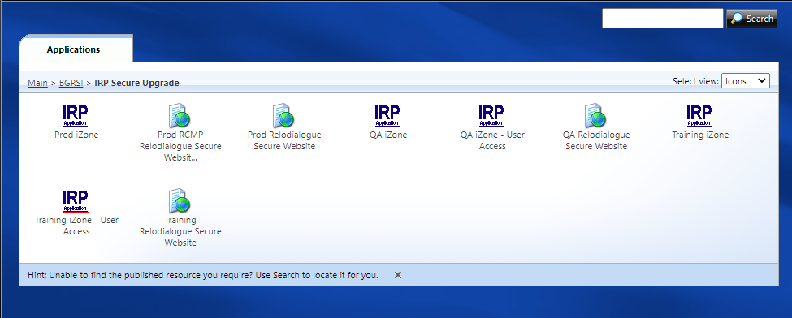
In iZone under the System Admin menu launch “Profile Maintenance”. 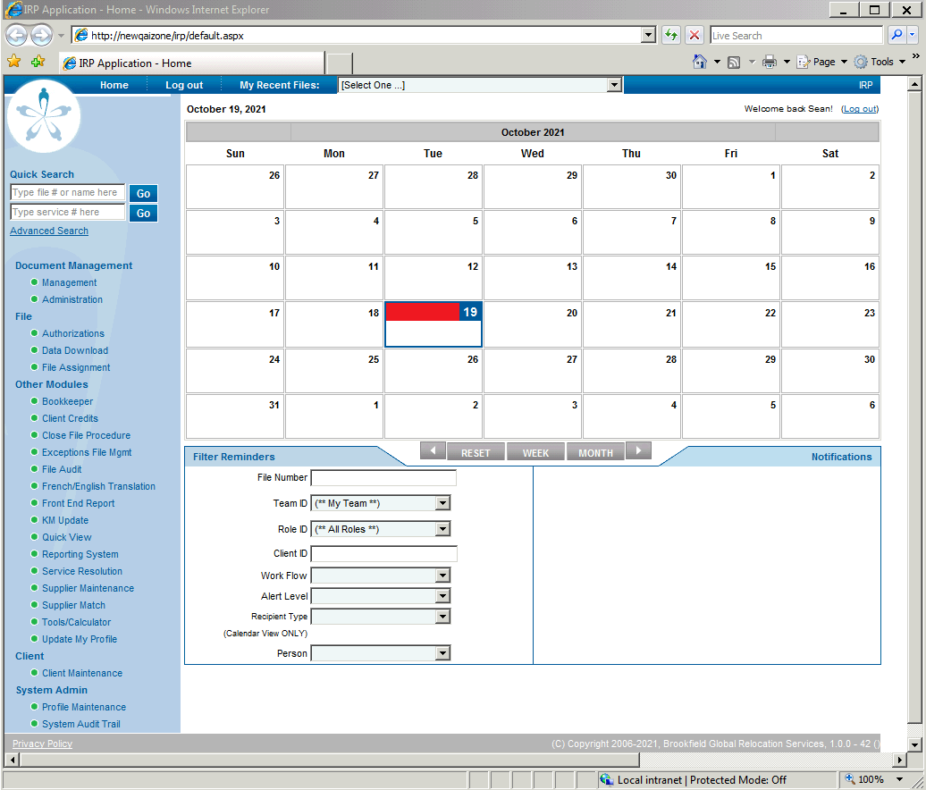
In Profile Maintenance enter the ID of the mirror account provided in the Login ID field and then click on list:
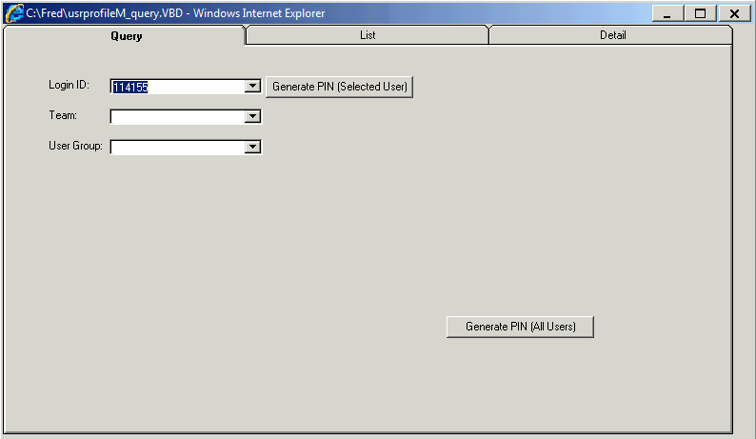

In the list tab select the username and then click on Details
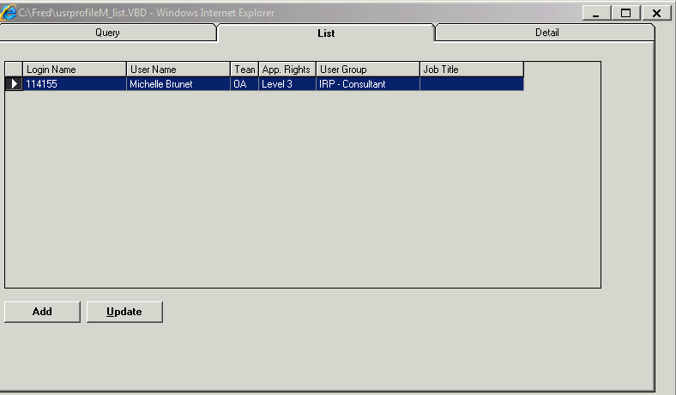

Here you will need to capture user specific details which you will need to apply to the new user account you will be creating. Taking a screenshot for reference is recommended.
- Team
- User Group
- Approval Rights
- Language
- Client Access
- Role
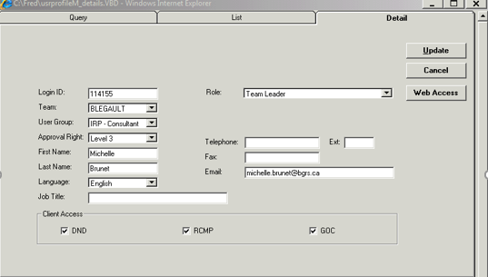
Next is to obtain the mirror account permissions. To do so open iZone User Access, enter the user ID into the Search Users field and click Go. Take a screenshot as well.
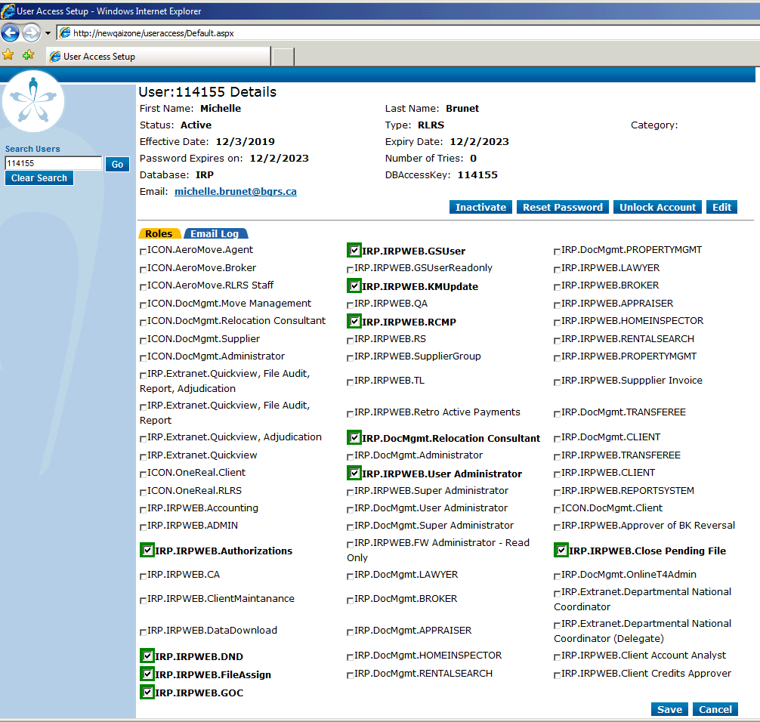

At this point we are now ready to create the new user with the captured attributes in the previous steps. Go back into iZone > Profile maintenance screen. Enter the new user’s ID in the Login ID field and then click list.
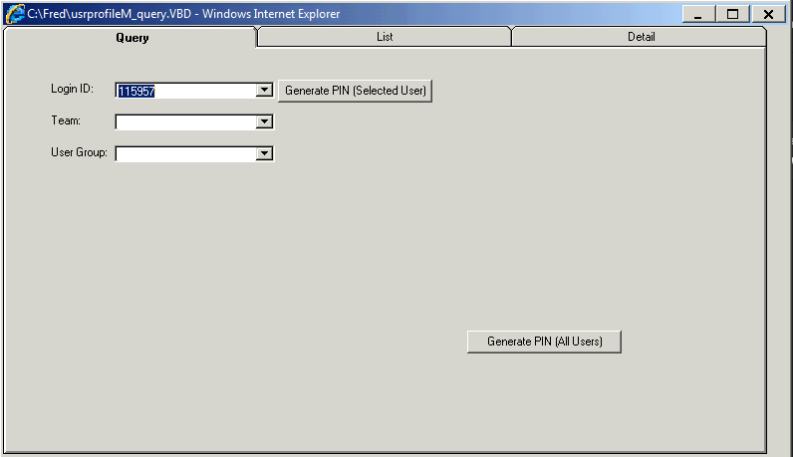

If no record is displayed, we know user does not already exist. At this point click on the Add button
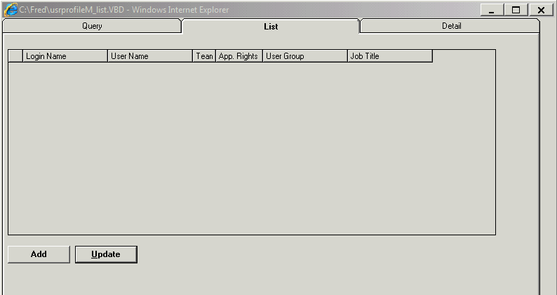

Populate the below fields with the data collected in your previous screenshot:
- Team
- User Group
- Approval Rights
- Language
- Client Access
- Role
For user’s personal attributes reference AD for:
- Login ID
- First name
- Last name
- Email Address
Once completed click on Save
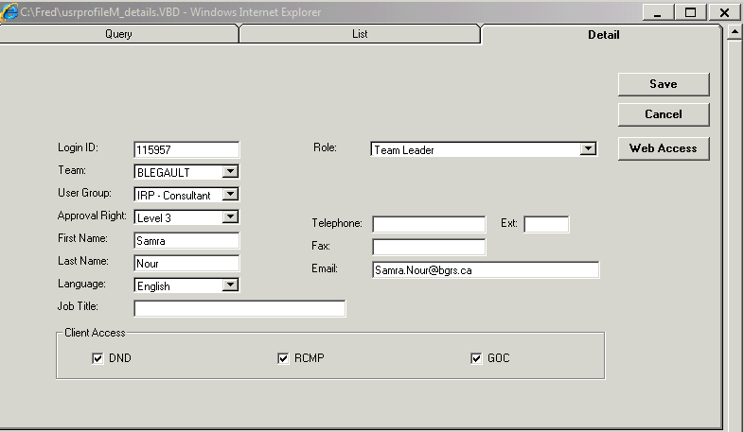
Click highlight the new user account and click on Update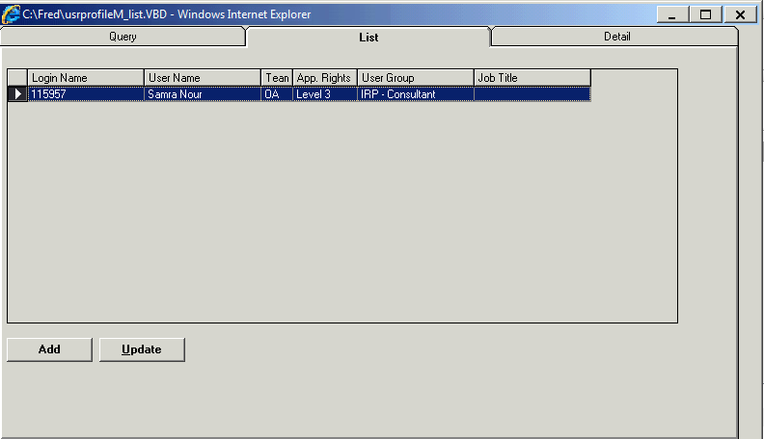

Click on Web Access
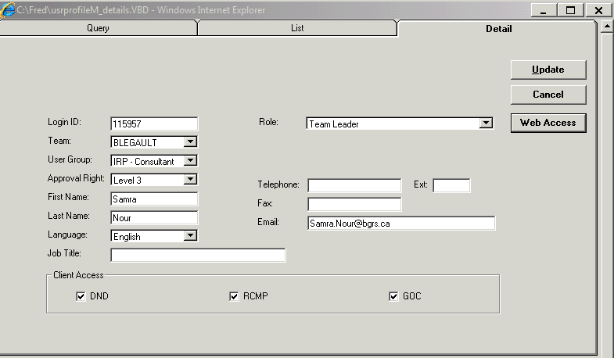
NOTE IMPORTANT. Copy the DB Access Key value into the USER ID Field and then click save.

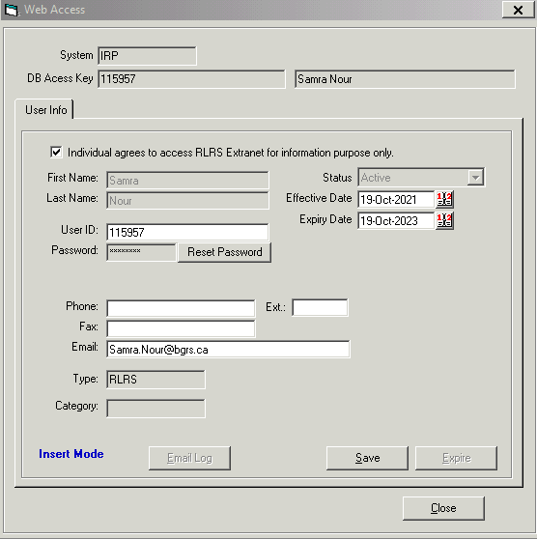
Click on Update
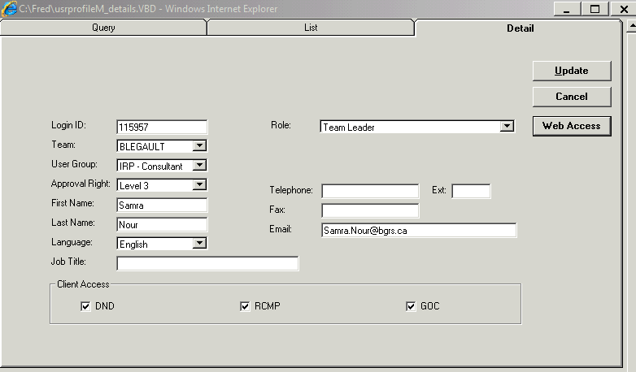

Go into User Setup and search the new user ID you created. Once you pull up the account add the permissions from the screenshot and click save
NOTE: If you ever need to add “IRP.IRPWEB.ReportingSystem” please inform Application Engineer as they will need to submit a DBCR.
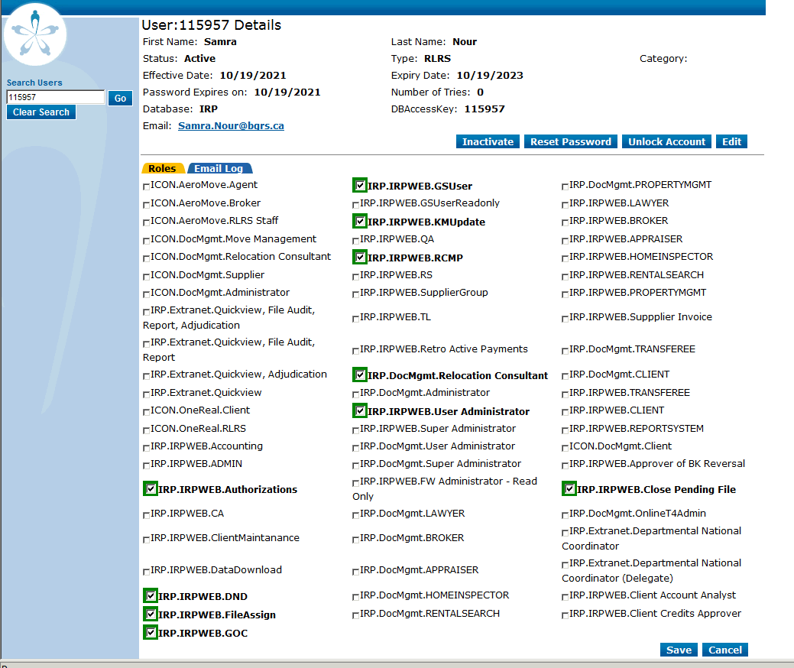

Now click on the Edit button and update the Password Expiry On to match the expiry date and then click save
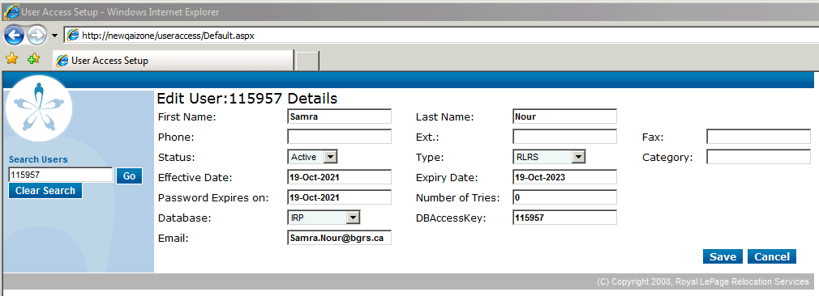

Click Save and then validate with the user.