Sirva team,
We are pleased to introduce a new print and scan solution with the new Canon devices called uniFLOW Online. Below are some of the functions available with uniFLOW Online:

Secure My Print Anywhere
Submit print jobs to a single queue. All print jobs stay in a secure print queue until a user authenticates at the Canon device with a PIN code. Print jobs follow users from device to device, allowing the release of print jobs on any Canon device. Users can also alter finishing options directly at the device before printing.

Scan to Cloud
Scan directly to the following destinations from the Canon MFP:
- Scan to Myself (email)
- Scan to Exchange Online (email to others)

Guest Printing
Guest print jobs can be submitted as follows:
- Submit email to mobileprint@sirva.us.uniflowonline.com
- If the email comes from an account that is not in uniFLOW Online, uniFLOW Online will send back a job code that the user than enters at the Canon MFP to release their job:
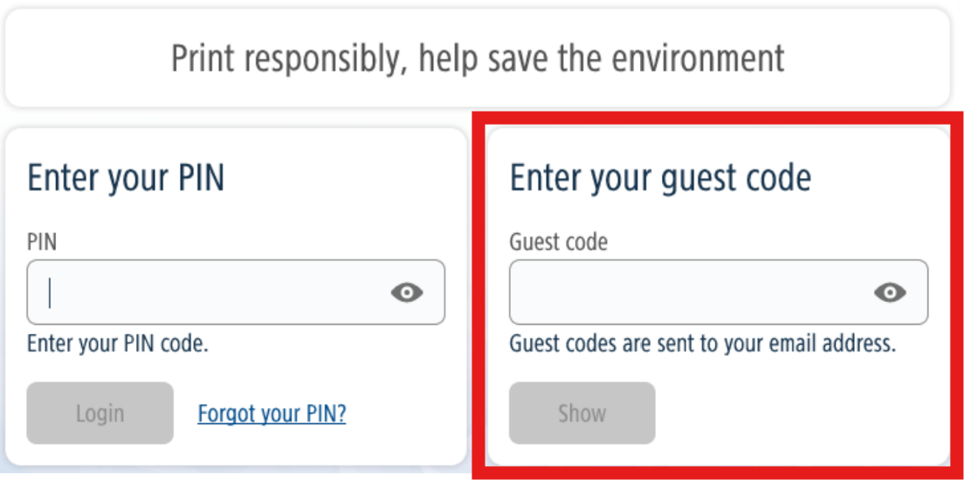

Mobile Printing
Mobile print jobs can be submitted multiple ways:
- uniFLOW Online Print and Scan app
- Submit email to mobileprint@sirva.us.uniflowonline.com
- Upload job via the uniFLOW Online tenant – https://sirva.us.uniflowonline.com

Let’s get started!
Please see the following guides for instructions on the one-time registration steps. The checklist below can be used as an aid to ensure all necessary steps are completed.

Register SmartClient*
Confirm you have received PIN code from canon_notifications@sirva.com
(PIN code is emailed after a user registers the SmartClient)

Register your badge at the Canon MFP*
Register to Scan to Exchange Online* (if you intend to use this function at the Canon MFP)
How to - Submit & Release Secure Print job
How to – Verify and/or Reset Pin Code

*one-time actions for initial onboarding

Step 1: Register SmartClient
The SmartClient deploys the print driver.

1 |   On your computer desktop,  click the uniFLOW Online SmartClient icon  in bottom-right tool tray.  uniFLOW Online webpage will launch.  If it does not appear in the tool tray or launch, please reboot your machine. | 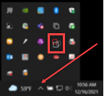
2 | Log into the uniFLOW Online tenant by selecting the Continue with Sirva Login  Sign-in with your SSO login. | 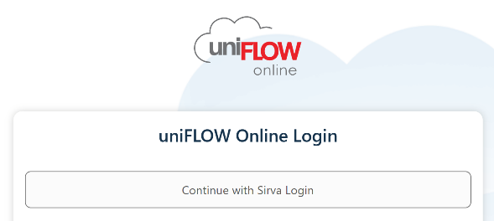
3 | A confirmation message will appear in your web browser once setup is complete. Please close this window or tab and minimize your browser. | 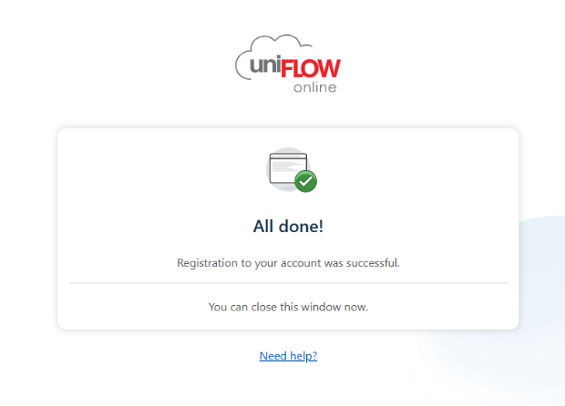
4 | Click on the uniFLOW Online icon on your taskbar and select Start to close this window. |   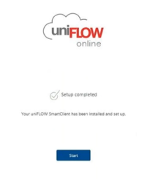

Step 2: Register your badge at the Canon MFP
Make note of the PIN code sent during Step 1 in email from canon_notifications@sirva.com before approaching the Canon multi-function printer.
Note: this is a one-time step. Once your badge is registered, it will be recognized at all the Canon devices connected to uniFLOW Online..

1 | At the Canon MFP, swipe your building badge over the embedded card reader. | 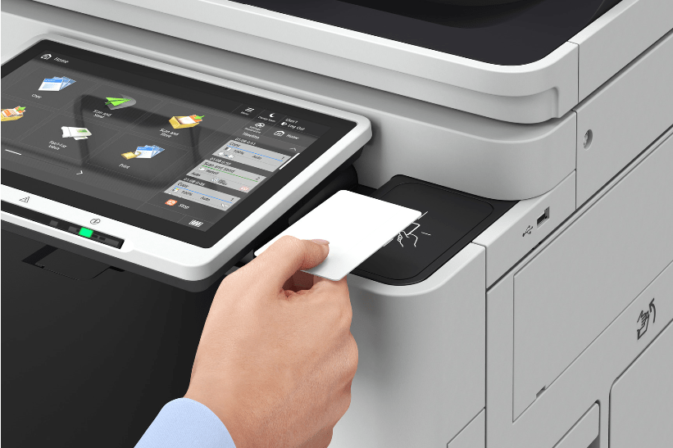
2 | When prompted for Card Registration Code,  enter the PIN code sent from  canon_notifications@sirva.com | 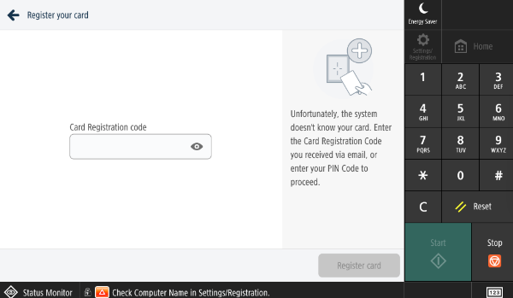
3 | Select Register card | 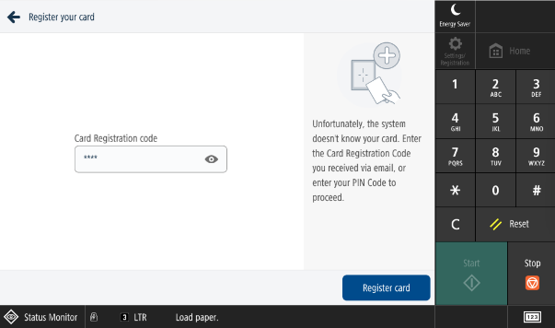
4 | Card registration succeeded will display on the device panel once badge is registered.  You may now login to the Canon via badge or PIN code and are now able to secure badge print. The remaining steps are optional and can be done at any time. | 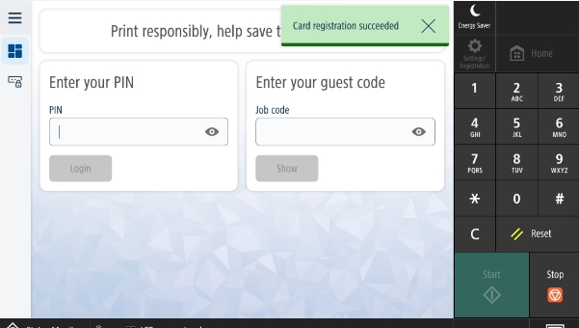

How-to | Submit Print Job to the Secure Queue

1 | Open a file at your computer.  Select File >> Print.  Select Canon Secure Print  Choose print options and print your file. | 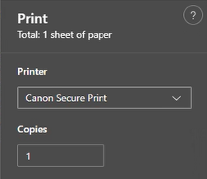
2 | At the Canon MFP, swipe your badge to print or enter PIN code to authenticate. | 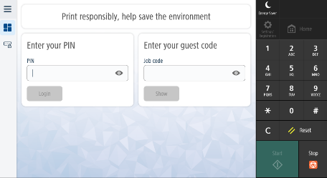
3 | Select the Secure Print from the Home screen | 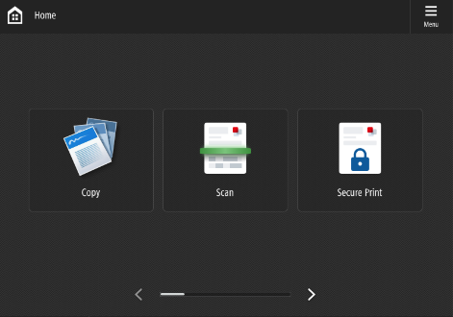
4 | To release print jobs, either:  - Swipe right on selected print job  - Highlight print job(s) and select Print  OPTIONAL: Select Edit to modify print settings such as # of copies, color, staple, etc. | 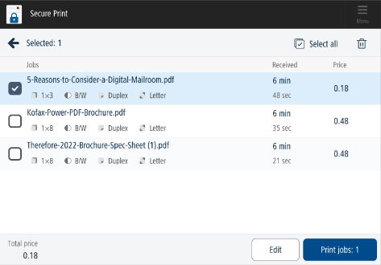
5 | IMPORTANT  Please remember to select Log Out before walking away from the Canon device.  NOTE - The below step is optional and can be done at any time. | 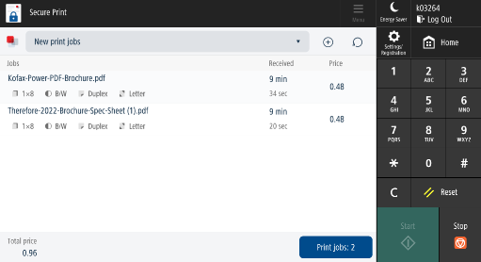

Step 3: Register to Scan to Exchange Online (optional)
This step is only required if you intend to utilize the Scan to Exchange Online feature which allows you to scan direct from the Canon MFP to other email addresses. Note: the Scan to Myself workflow can be utilized when scanning to self.
1 | Log into the uniFLOW Online tenant https://sirva.us.uniflowonline.com  by selecting Continue with Sirva Login .  Sign-in with your SSO login.
2 | Locate the Notifications window within the Dashboard screen. | 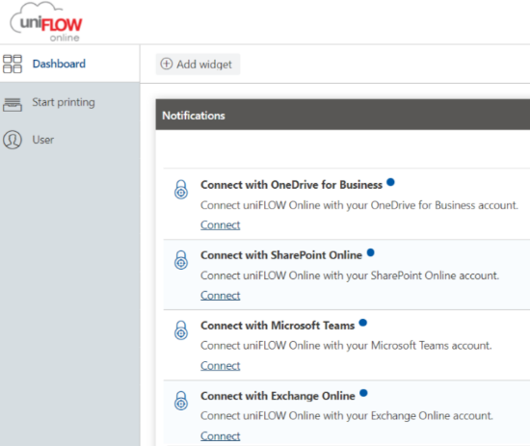
3 | Select Connect for each destination  you intend to scan to from the  Canon multi-function printers.
4 | Select Authorize on pop-up screen. | 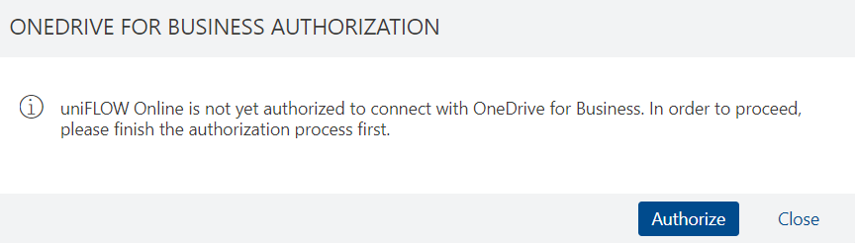
5 | Log in with your SSO to authorize. | 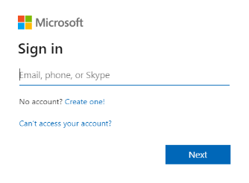

How-to | Verify or Reset PIN code
1 | Log into the uniFLOW Online tenant  https://sirva.us.uniflowonline.com/  by selecting Continue with Sirva Login  Sign-in with your SSO login.
2 | Select the Dashboard tab | 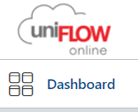
3 | Highlight the PIN row under Identities  Place cursor to the end of row to select the 3 dots to select either:  Show PIN code or Delete identity*  *If you delete identity, move forward to Step 4 | 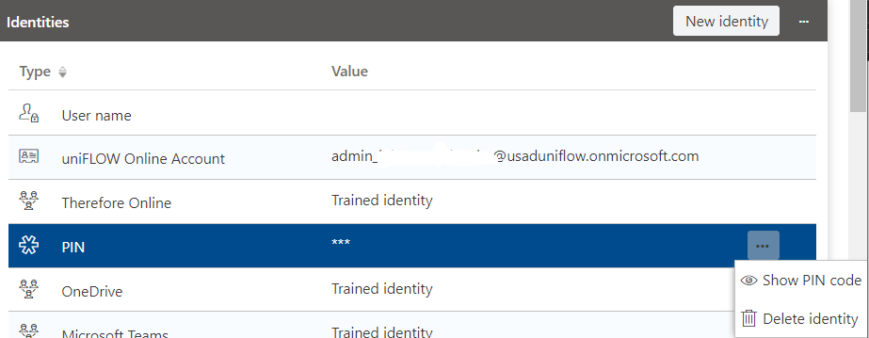
4 | To re-issue a new PIN code,  select +Add Identity | 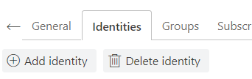
5 | Select PIN from the Identity type drop-down  Select Save | 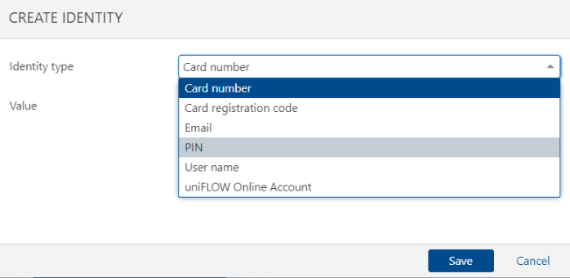
6 | uniFLOW Online sends end user an email with new PIN code.

