Contents

1. Introduction 2
2. Change Management Life Cycle 2
3. Change Windows and Guidelines 2
4. Using the RFC Form 3
4.1 Using the RFC Toolbar 3
4.2 Workflow Status Bar (Change Request Life Cycle) 4
4.3 RFC Data Fields / RFC Form 5
4.4 Overview of RFC Tabs 8
4.4.1 Overview of Description Tab 8
4.4.2 Overview of Business Risk Tab 9
4.4.3 Overview of Testing Details Tab 9
4.4.4 Overview of Analysis Tab 10
4.4.5 Overview of Implementation Tab 10
4.4.6 Overview of Post Implementation Validation Details Tab 12
4.4.7 Overview of Related Items Tab 12
4.4.8 Overview of Attachments Tab 12
4.4.9 Overview of Approval Tab 13
4.4.10 Overview of History Tab 13
5. Overview of RFC Workflow 14
6. Email Notifications 15
7. Using the Change Calendar 15

ChangeGear – User Manual

1. Introduction

The ChangeGear Tool, available via the Web, lets you perform the functions necessary to successfully complete the change request process. This document is drafted to provide step by step guidance on how to use the tool for submitting and implementing change requests.

2. Change Management Life Cycle

Change management directs change requests through a life cycle that includes several stages.
3. Change Windows and Guidelines
Daily and Weekly Change Windows:
The Daily Change Window is when we implement all normal, risk level 4 changes. It happens Monday-Friday, from 4pm ET/3pm CT to 12am ET/11pm CT.
The Weekly Change Window is when we implement all normal changes of all risk levels. It starts every Saturday, 9pm ET/8pm CT to Sunday, 5am ET/ 4am CT.
RFC Submission Deadlines:
All the Risk Level 4 changes for the day should be submitted by 1:00 PM ET. Expedited and Emergency changes are exceptions.
All Risk Level 1, 2 and 3 changes for the week should be submitted by every Wednesday@1:00 PM ET.
Approvals:
Risk Level 4 changes are reviewed and approved by Application owner, CM group.
Risk Level 1, 2, 3 changes will be reviewed and approved by Application Owner, CM group, IT Teams, Security Team.
Expedited and Emergency changes will be reviewed and approved by VP, Application Owner and CM Group. Business Justification will be required for all Expedited and Emergency Changes.
Weekly CAB Call:
Weekly CAB Call is held every Thursday@ 12:30 PM ET. All Risk Level 1, 2 and 3 changes will be reviewed.
Risk Level4 and Datafix changes are an exception.
Production Database Access Requests: We will be leveraging the Zendesk tool for any Production database access requests. If access is required, SAR form needs to be filled out.
Database Access Request Form (office.com)
Once the form is filled, the request will be reviewed and approved by the requestor’s Manager, followed by the Security Team and VP. Once the request is fully approved Zendesk ticket will be created and assigned to Database Team for providing access. The access must be removed after the specified period, the ticket will be left open until the access is removed. After the access is removed the ticket will be closed.

4. Using the RFC Form

The ChangeGear RFC form is comprised of below parts:

▪ RFC Toolbar
▪ RFC Workflow Status Bar
▪ RFC Data Fields / RFC Form
▪ RFC Tabs

4.1 Using the RFC Toolbar

The RFC toolbar lets your complete tasks throughout a change management life cycle. The toolbar provides command buttons in the form of icons.

NOTE: Some of these icons are only available when you are performing unique processes in the life cycle.

4.2 Workflow Status Bar (Change Request Life Cycle)

ChangeGear uses a workflow status bar to represent each of the process stages a change request must go through before it is successfully implemented and closed. The workflow tracks the entire process from the submission of a change request (New) throughout the life cycle until the request is successfully closed (Closed).

Understanding the RFC Status Field

The status field of the RFC indicates where the ticket is in its life cycle. The default setting for a new ticket is New and the status when completed is Closed. Below are various statuses and description of each.

- Unsubmitted – When the change is being Drafted
- New – When the change is submitted
- Approval – When the change is sent for approvals and awaiting approvals
- Assign – When the change fails validation and needs to be backed out
- InProgress – When the change is approved and Implementation is InProgress
- Validation – When the change is implemented and is being validated
- Closed – When the change is completed and marked as closed.
RFC Close Types: Close Types are reasons describing the reason a change request was closed. When an RFC is being closed the close type should be selected. Below are the existing close types.

- Cancelled
- Rolledback
- Unsuccessful
- Successful

4.3 RFC Data Fields / RFC Form

The RFC data field is the main information section for the RFC. The RFC form is designed to gather all necessary information regarding the Change.

Note: All the fields marked in * are mandatory fields. Change Record cannot be submitted if the mandatory fields are not filled.

Requester Details: Whenever a new RFC form is opened, ChangeGear automatically populates the Requester name, E-Mail address, Location, Department, and Created Date/Time fields.

If you want to change the Requester, begin to type the name in the Requester field or select the name from the dropdown menu.

Summary: Summary Field is where the requester should be entering the Title of the RFC.

RFC result of an Incident, Problem or Defect: Dropdown field with Yes or No options. If the option is chosen as “Yes” there will be an additional text box Ticket# to add Zendesk ticket or defect’s.

Priority: Priority is classified into Critical, High, Medium, Low. Choose the Priority from the Dropdown Menu.

Change Reason: Choose the appropriate change reason from the dropdown Menu.

Change Type: Select the appropriate change type (Emergency, Expedited, Informational, Normal, Routine) from the dropdown Menu. Business Justification is required to be added in the text field if the change type is selected as Emergency or Expedited.

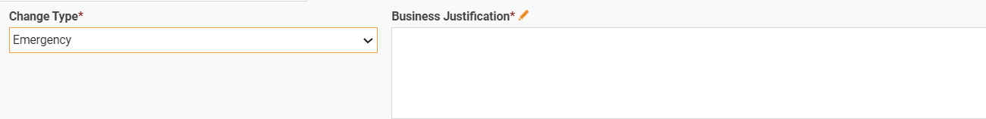

Application(s) Impacted: This field is a dropdown field which would allow you to Select the right applications. This field is also a Multiselect field which means it would allow to choose multiple applications at once. To select applications, click on the dropdown Menu, select the application and click on ‘+’ symbol. Repeat the process if you would like to add multiple applications.

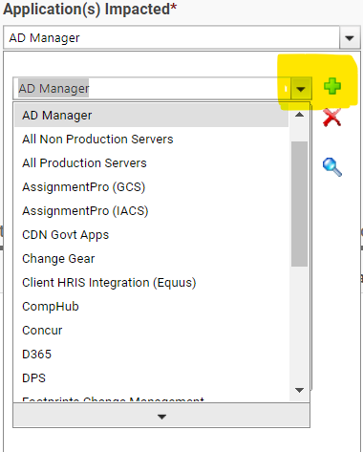

BU’s Impacted: This is also a dropdown field with Multiselect feature which would allow to choose multiple BU’s.

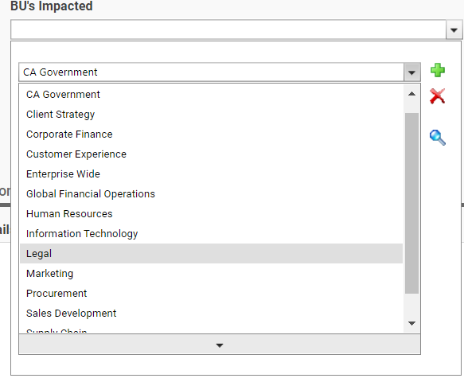

Outage Required: Dropdown menu with Yes or No. If Outage Required is chosen as ‘yes’ there would be an additional text box to add Outage Details such as outage duration, outage start and end time etc.

Also, there will be an additional questionnaire if communication is required. This is a dropdown with Yes or No. If the answer to communication required is chosen as ‘Yes’, an additional text box would appear to add communication details such as who should be notified, when should the communication be shared etc.

Deployment to DR Site: This field is a drop-down field with Yes or No options. If the answer is No, there would be an additional text box to add Reason for no deployment to DR Site. Justification to be added by the requester if the requested change is not deployed to DR Site.

4.4 Overview of RFC Tabs

The RFC form displays a row of tabs. Each Tab has various questions and details that are required for a change. These tabs serve as a record of data gathered, testing done, decisions and actions at each stage of the process and can therefore be used as an audit trail of the change request.

Overview of Description Tab

The Description tab allows you to enter text and/ or notes related to the ticket. The Description field lets you enter overview of the change.

The Notes field provides a chronological view of notes added to the ticket. When a user enters an entry, ChangeGear captures the name of the person adding to the field as well as the time and date of the new entry. Once the ticket is saved, entries become read-only.

To add a description:

1. On the RFC form, click the Description tab.
2. Under Description of Change, enter change details.
To add notes / Technical Details:

1. On the RFC form, click the Description tab.
2. In the Notes field, Enter any notes or Technical Details.

Under the Description Tab there is also a questionnaire about Roll Back.

- Roll Back Duration: Enter the duration to Rollback if a change needs to be rolled back. The Rollback duration should be included within the change window.
- Roll Back Steps: Steps to perform a Roll back can be included in this section. Also rollback scripts can be attached.

4.4.2 Overview of Business Risk Tab

This Tab includes 6 Risk Questions which would calculate the Risk Score and Risk Level based on the answers provided for each question. Requestor would require answering all the questions.

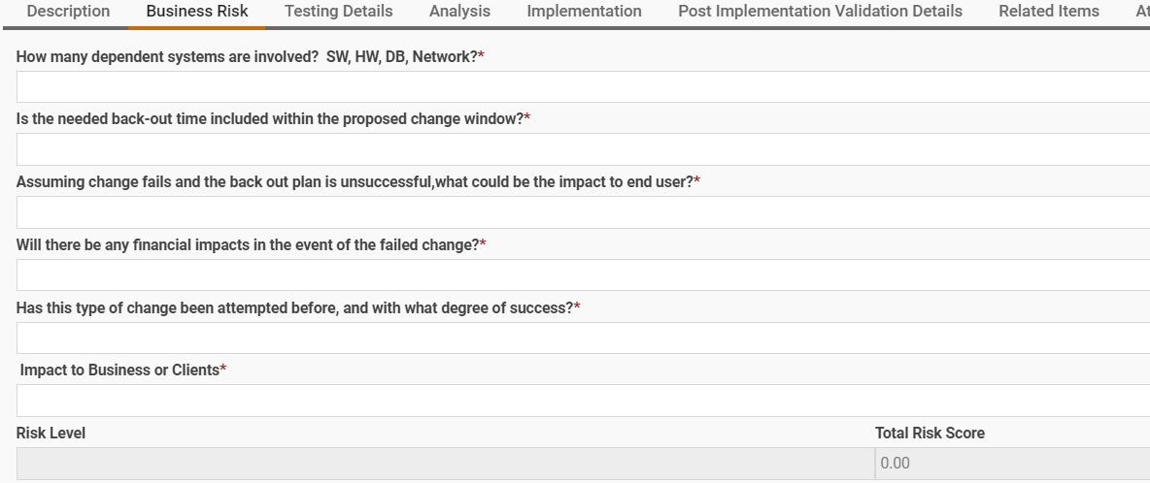

Overview of Testing Details Tab

**Every change needs to be tested prior to Implementation**
Has this change been tested prior to implementation:
- Yes: If Yes, Attach QA, UAT, Stage Sign off. The Change Management team would verify if the change has been implemented and tested prior to approving the change.
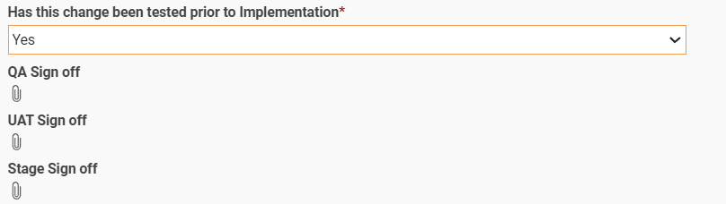
- No: If No is selected, there would be a text field to explain why testing the change is not required.
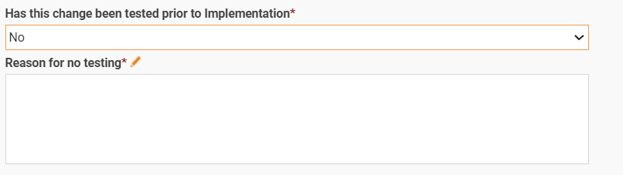

4.4.4 Overview of Analysis Tab

Planned start and planned complete fields need to be updated in this Tab. The date and time fields can be added by clicking on the calendar icon.
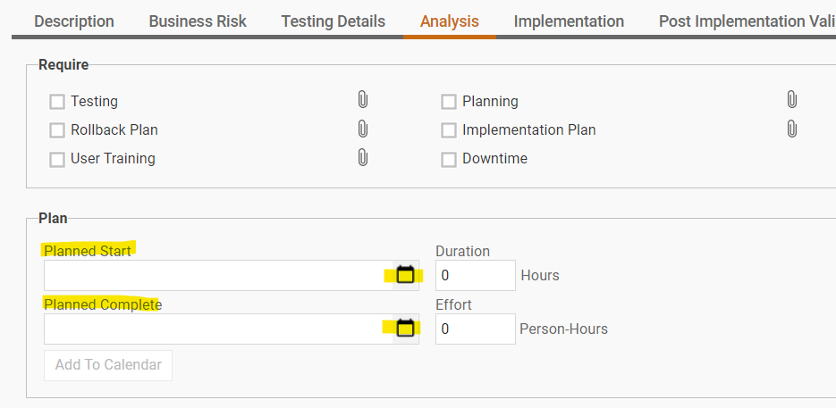
A calendar would appear at the bottom, double click on the date. A window will appear to select the date and time. Once the date and time are chosen click OK for the fields to be updated in the RFC or type in the date and time in the planned start and complete fields.

4.4.5 Overview of Implementation Tab

The change owner uses this tab to plan individual tasks for each implementation team. Various tasks can be created under this Tab.

To create a new task: Go to implementation Tab, Click on New on the Top Left corner.

This would open a new Task.

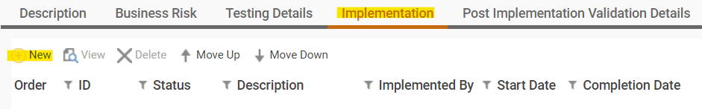

Each newly opened Task would have below information

- Tasks must be assigned to the Implementors. Implementer Name can be updated by selecting the name from the Dropdown field.
- Implementation Instructions can be added under Implementation details.
- Start and Completion date and time should also be included for each task.
- Any additional notes can also be added.
- Once the Task is created it can be saved by clicking on Save.
- Once the change is approved, Task Implementer would be required to Accept the task by clicking the Accept Task button which is present on the top of the Task window. Once the Task is completed it needs to be closed by clicking Close Task. These actions are important as it would calculate the actual start and actual finish date and time and also to automatically update the status of the RFC from In-Progress to Validation.
- Same actions should be performed for all the tasks.

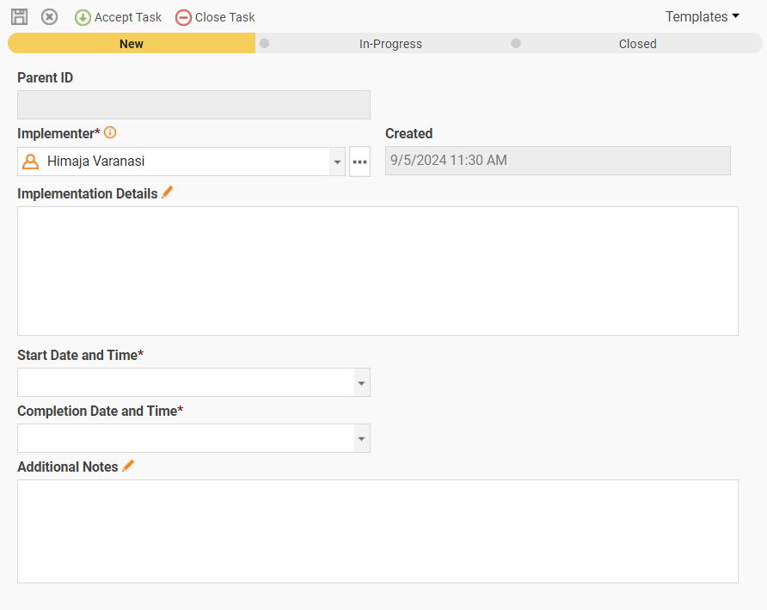

4.4.6 Overview of Post Implementation Validation Details Tab

Every change that is deployed should be validated. This tab allows the requestor to add details regarding post implementation validation.

Requestors should add Post Implementation Validator’s name(s) and Validation Steps.

4.4.7 Overview of Related Items Tab

Under this Tab requestors can relate / link various RFC’s.

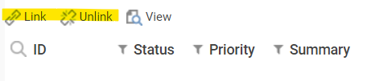

To link to a related item:

- Click the Link button in the Related Items toolbar. The Link Item dialog appears.
- You can search the RFC that you want to link by entering RFC number or with the summary.
- Select an item and click Add.
- After you are done adding items, click OK.
- Your RFC will now have related items in the tab.

4.4.8 Overview of Attachments Tab

The Attachments tab lets you add, remove, and review files supporting anything you deem necessary for the change request.

To add an attachment using the Attachments tab:

Under the Attachments tab click add, choose and attach the relevant files.
You can also enter a descriptive name of the attachment. Entering a descriptive name allows users to quickly know the purpose of the attachment.

To remove an attachment:

You can remove obsolete, erroneous, or irrelevant files.

1. In the RFC form, click the Attachments tab.
2. In the Attachments list, select that attachment or attachments you want to delete.
3. Click Remove.

4.4.9 Overview of Approval Tab

Approval is a formal decision to implement or reject a change request. Information previously collected for the change request plays a vital role during this phase of the change management life cycle.

Under this Tab users would be able to see all the approvals along with the decision of each approver. If a change is rejected by any approver it would be visible under this tab.

Approvals are based on the Applications Impacted field. When an application is selected the approval group is automatically added and notification to respective approvers would be sent once the CM team reviews the change.

4.4.10 Overview of History Tab

Each time a ticket is modified, the modification is logged in the History tab. In addition to entries made automatically by ChangeGear, you can manually add comments to this log.

To view a history comment:

1. Open a Change ticket.
2. Click the History tab.
3. Select the history comment that you want to view.
4. Click View.
5. The upper portion of this page displays the list of fields modified as part of the action that led to this history entry.
6. Click OK or Cancel when you are done viewing the comment.

To add a comment under history tab:

- Click Add in the toolbar under History Tab.

2. Enter the text of your comment.
3. Click OK when done. Close the dialog.
4. Click Save from the form toolbar to save your comment.

5. Overview of RFC Workflow

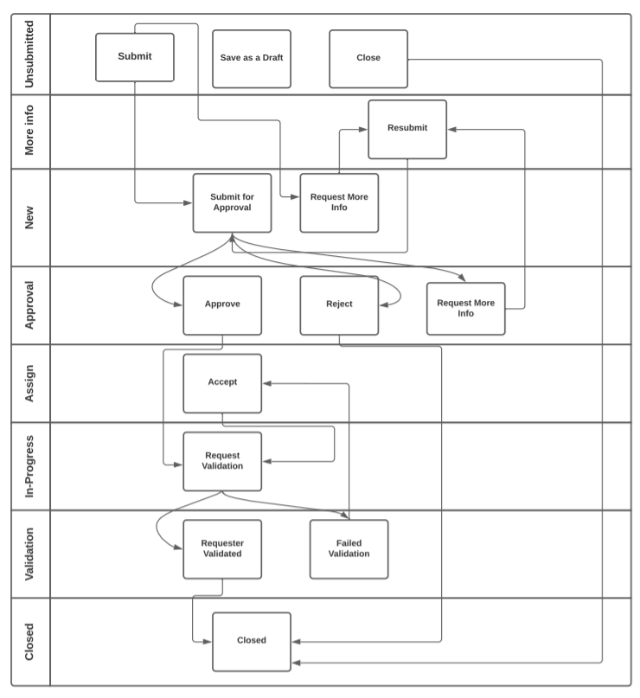

6. Email Notifications

Email automations are enabled for specific actions and specific workflow statuses. Below is the list of available email notifications. When a certain action is triggered, applicable email notifications will be sent to the recipients.

Email Notification | Recipients
When a change is Submitted | CM Team will be notified
When a change requires more info | Requester of the change will be notified
When a change is sent for approvals | Approvers will be notified
When a change is rejected | Change requester will be notified
When an approver requires more info | Change requester will be notified
When a change is approved | Change Requester and Implementors will be notified
When task(s) are completed | Change requestor and Implementors will be notified about validation
When change is validated | Change requester will be notified
When a change fails Validation | Change requester will be notified
When a change is not closed 48 after Implementation | Change requester will be notified once in a day after 48 hours past implementation time

7. Using the Change Calendar

The Change Calendar provides a monthly view of change requests organized by date. By default, it displays a timeline view of requests according to their start and end dates.

To open the Change Calendar:

1. Navigate to the Workspace from the ChangeGear primary navigation menu.
2. Click on Change events under other views.

