**VPN Login for Mobile Soft Token(Canada)**

1. Open Cisco AnyConnect on your login screen for windows with the icon with 2 monitors in the bottom right corner of window.

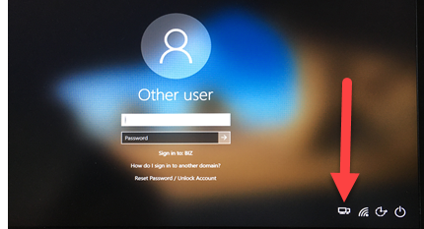 

1. Select the **VPN CANADA** location from the drop down:

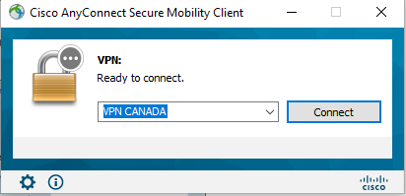

1. Click **Connect** and you will get the following login:

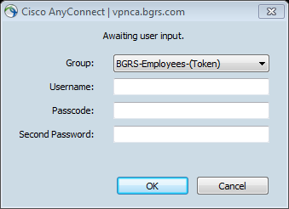

1. Enter your Windows username in *“Username”* field.
2. Launch the RSA SecurID Software Token application on your cell phone. Enter your 4-8 digit pin and hit **Submit** then enter the 8 digit number provided into the *“Passcode”* field.

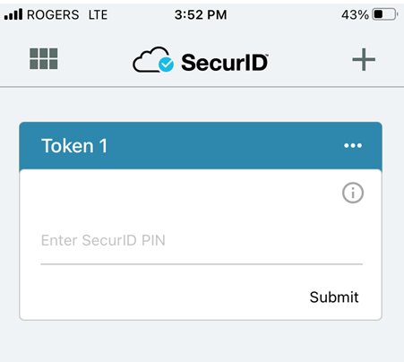 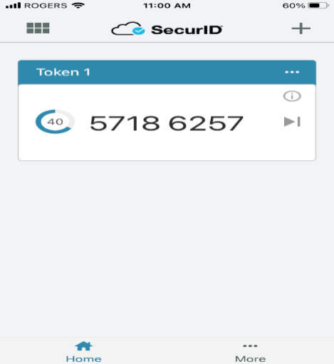

 EXAMPLE - You would enter 57186257 into the *“Passcode”* field.

1. Enter your Windows password in the *“Second Password”* field.

1. Click on **Accept** to connect to VPN.

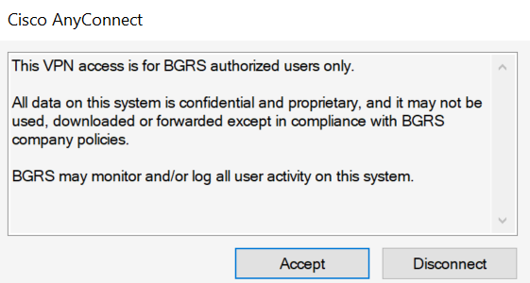

1. Now that VPN is connected you will login to Windows with your User ID and Network Password.