**VPN Login for Mobile Soft Token(US & International)**

1. Open Cisco AnyConnect on your login screen for windows with the icon with 2 monitors in the bottom right corner of window.

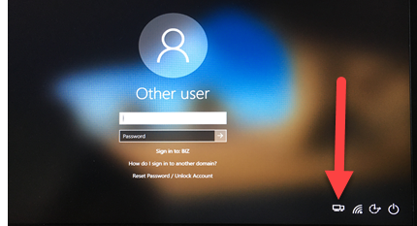 

1. Select appropriate VPN location(**VPN United States/VPN APAC/VPN UK**) from drop down:

EXAMPLE - **VPN UNITED STATES**  
 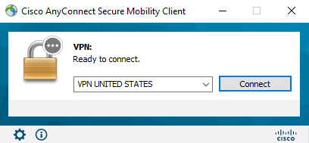

1. Click **Connect** and you will get the following login:

EXAMPLE - **VPN UNITED STATES**

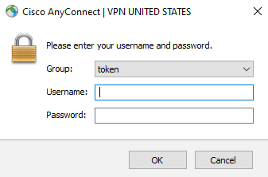

1. Enter your Windows username in *“Username”* field.

1. Launch the RSA SecurID Software Token application on your cell phone. Enter your 4-8 digit pin and hit **Submit** then enter the 8 digit number provided into the *“Password”* field.

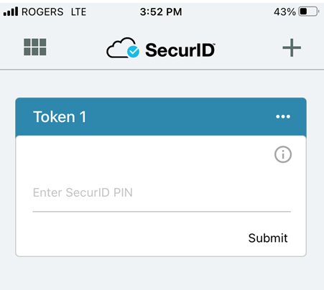 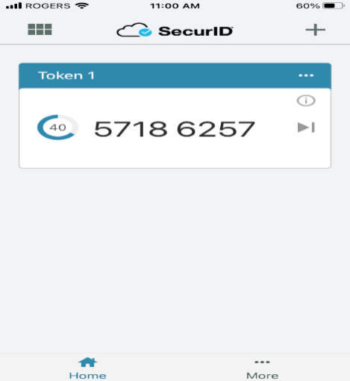

 EXAMPLE - You would enter 57186257 into the *“Password”* field.

1. Click on **Accept** to connect to VPN:

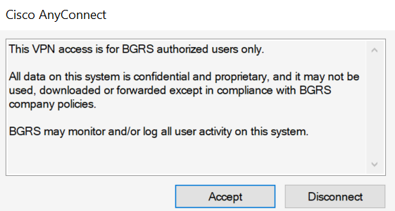

1. Now that VPN is connected you will login to Windows with your User ID and Network Password.